*Deepa Esturi*

*7/17/25*

*8/11/25 due*

Capstone Project 3 - API Endpoints and Communications

Travel Company Booking MicroService

**Pre-Requisites:** Junit, Spring, Spring Boot, Web Services, MicroServices

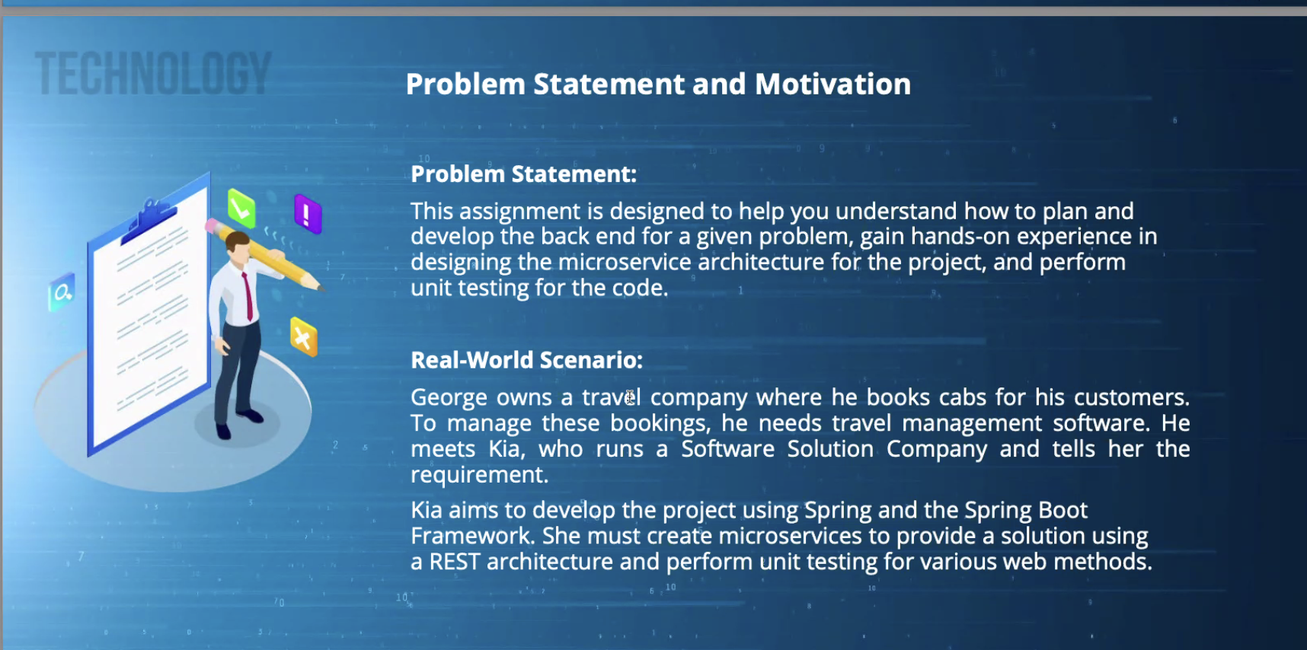

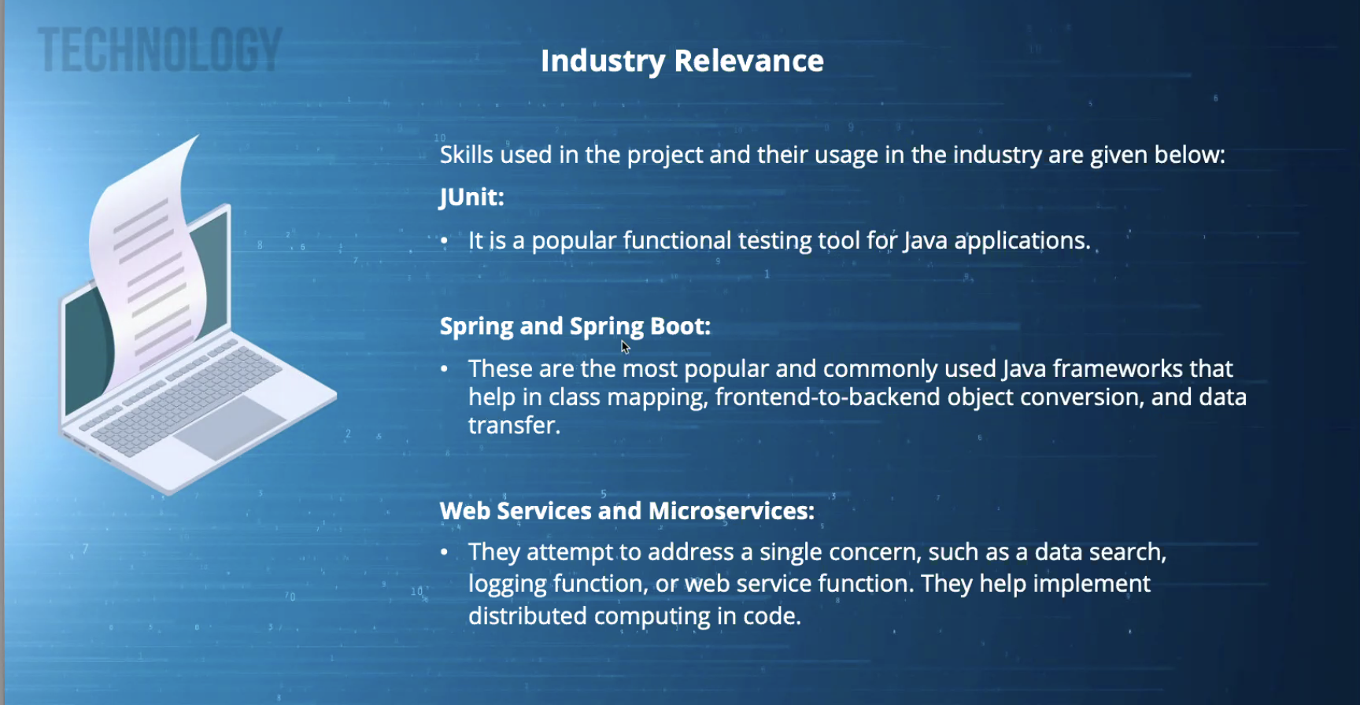

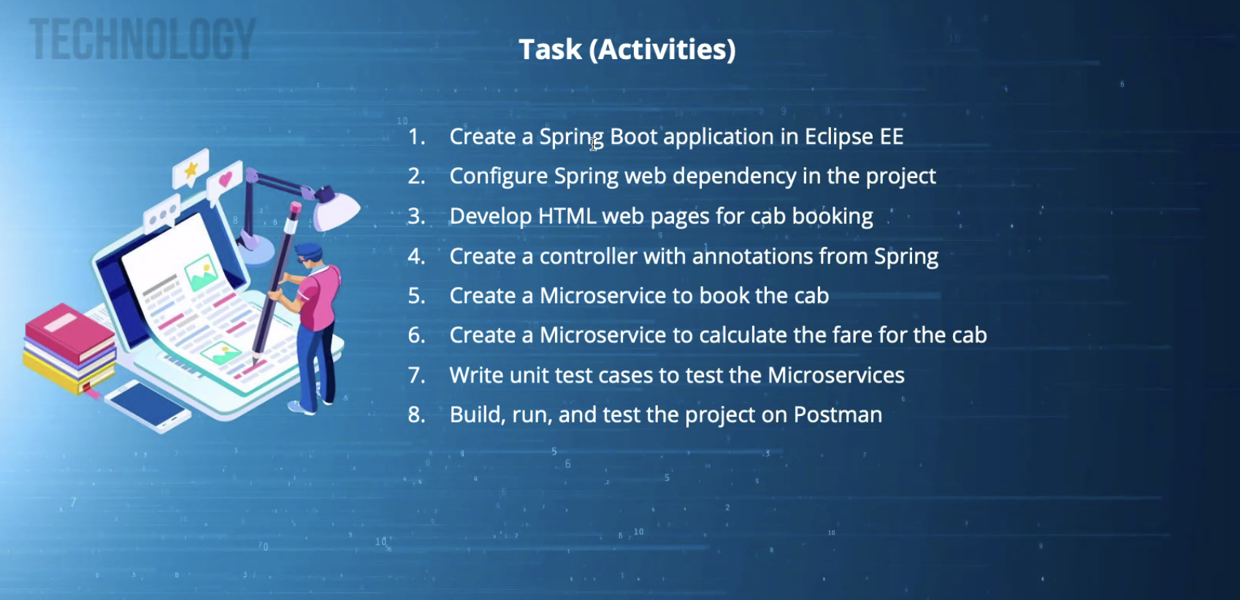

# Steps Adopted to Complete this Project:

## Step1: To create Spring CLI Maven CLI

<https://docs.spring.io/spring-boot/cli/installation.html> — Click on this link: [Installing the Spring Boot CLI](https://docs.spring.io/spring-boot/installing.html#getting-started.installing.cli)

Used Homebrew to install the Spring Boot.

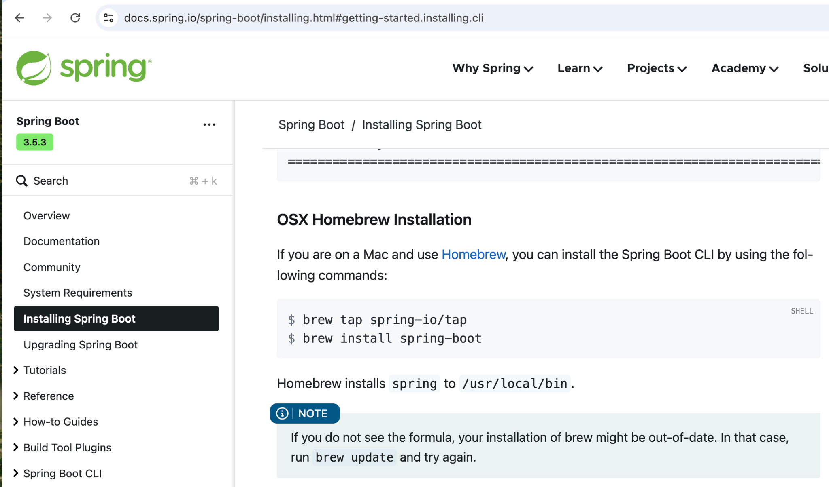

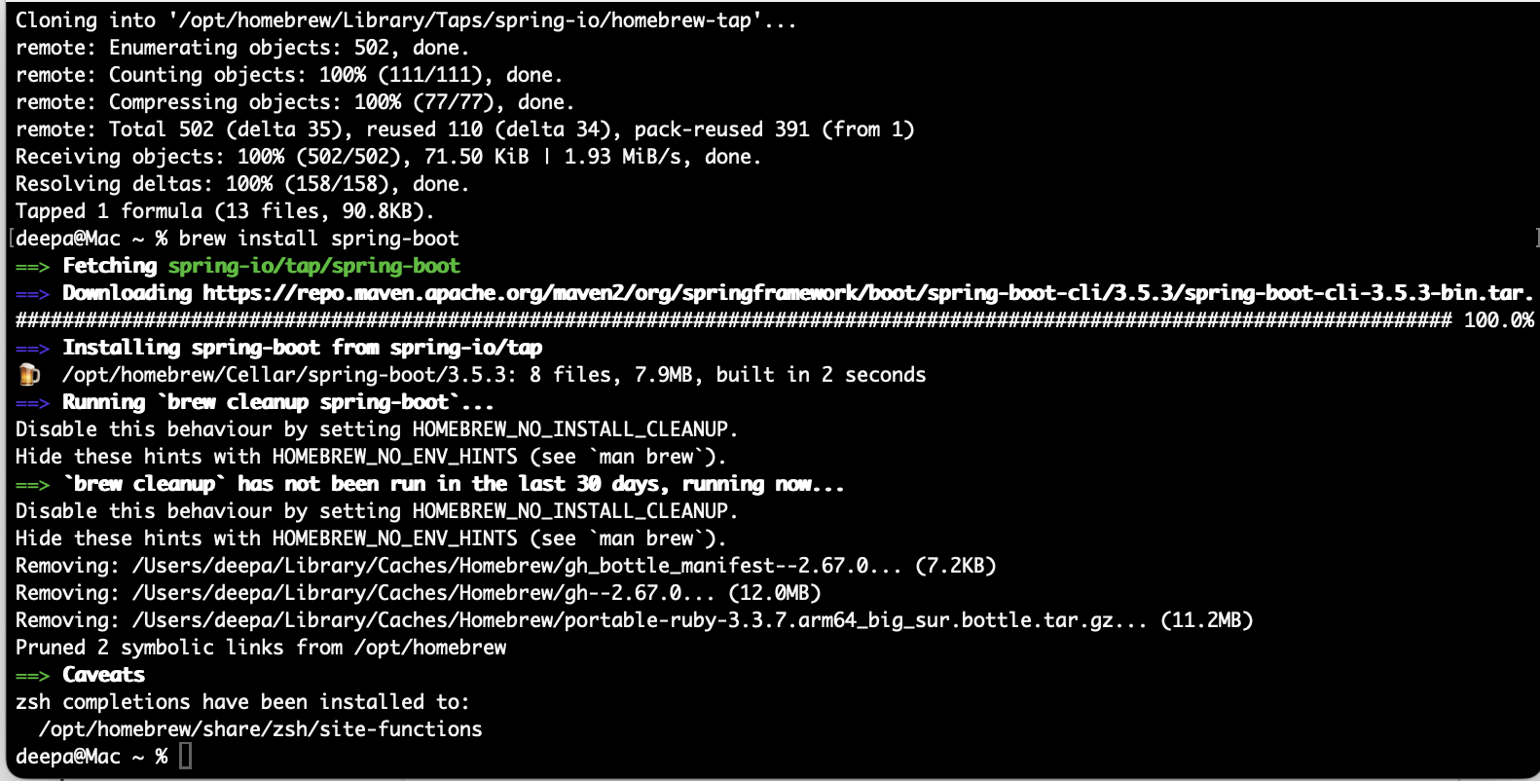

**Install maven CLI**

[**https://formulae.brew.sh/formula/maven**](https://formulae.brew.sh/formula/maven)

**brew install maven**

## Step2: spring initializr

<https://start.spring.io/>

Task1: Create a Spring Boot application in IntelliJ

Task 2: Configure Spring web dependency in the project

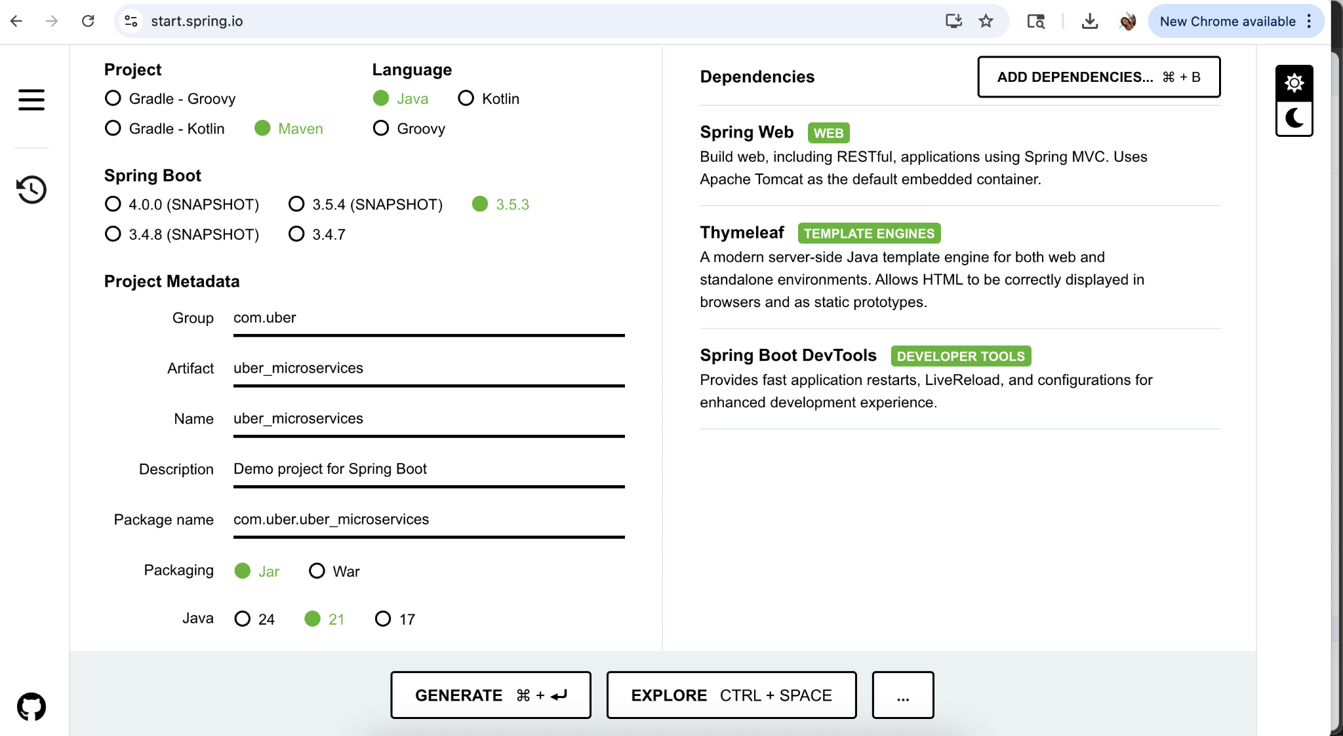

OR

Create parent project using Maven archetype:

mvn archetype:generate -DgroupId=com.uber \

-DartifactId=uber_microservices \

-DarchetypeArtifactId=maven-archetype-quickstart \

-DinteractiveMode=false

cd uber_microservices

## Step 3: Created a Unit3 project folder

1. Created “Unit3-APIEndpointsAndCommunications”
2. cd Unit3-APIEndpointsAndCommunications
3. Unzip the the uber_microservices Spring Boot application

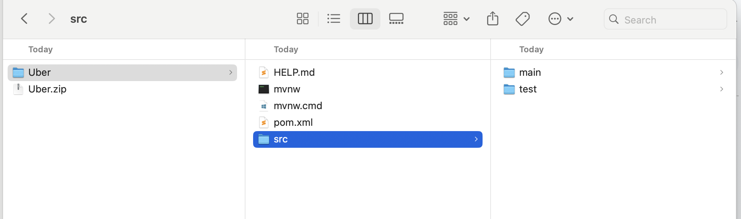

## Step 4: Remove src and .mvn folder

# Clean up generated files we don't need >> rm -rf src/

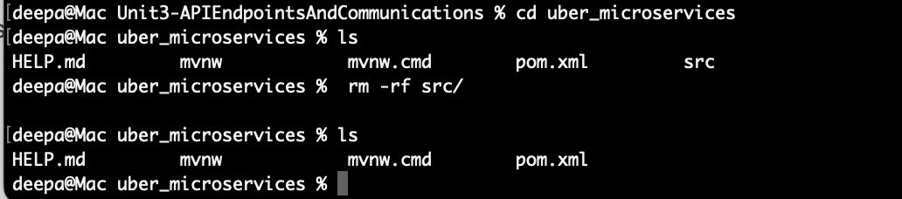

After you delete the src and .mvn folder

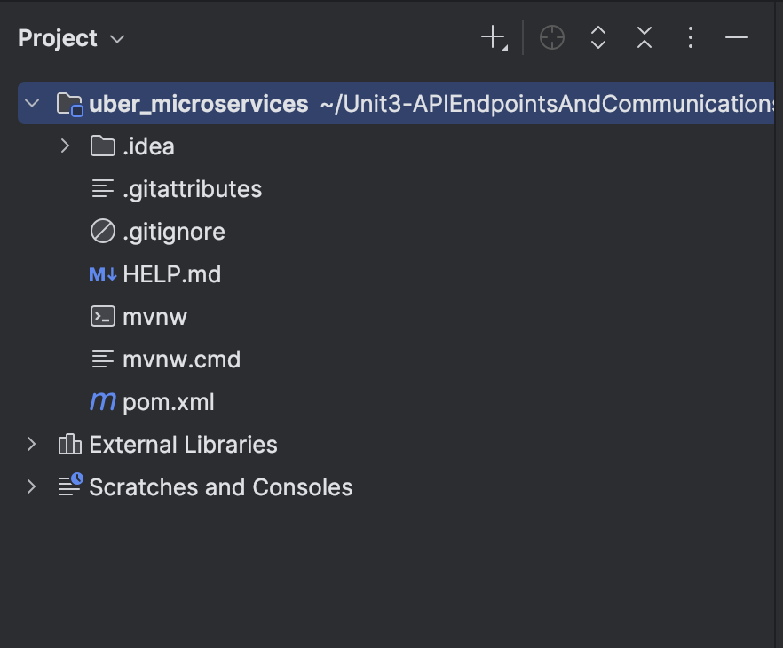

## Step 5: Add modules to the pom.xml

<modules>

<module>api-gateway</module>

<module>eureka-server</module>

<module>booking-service</module>

<module>pricing-service</module>

</modules>

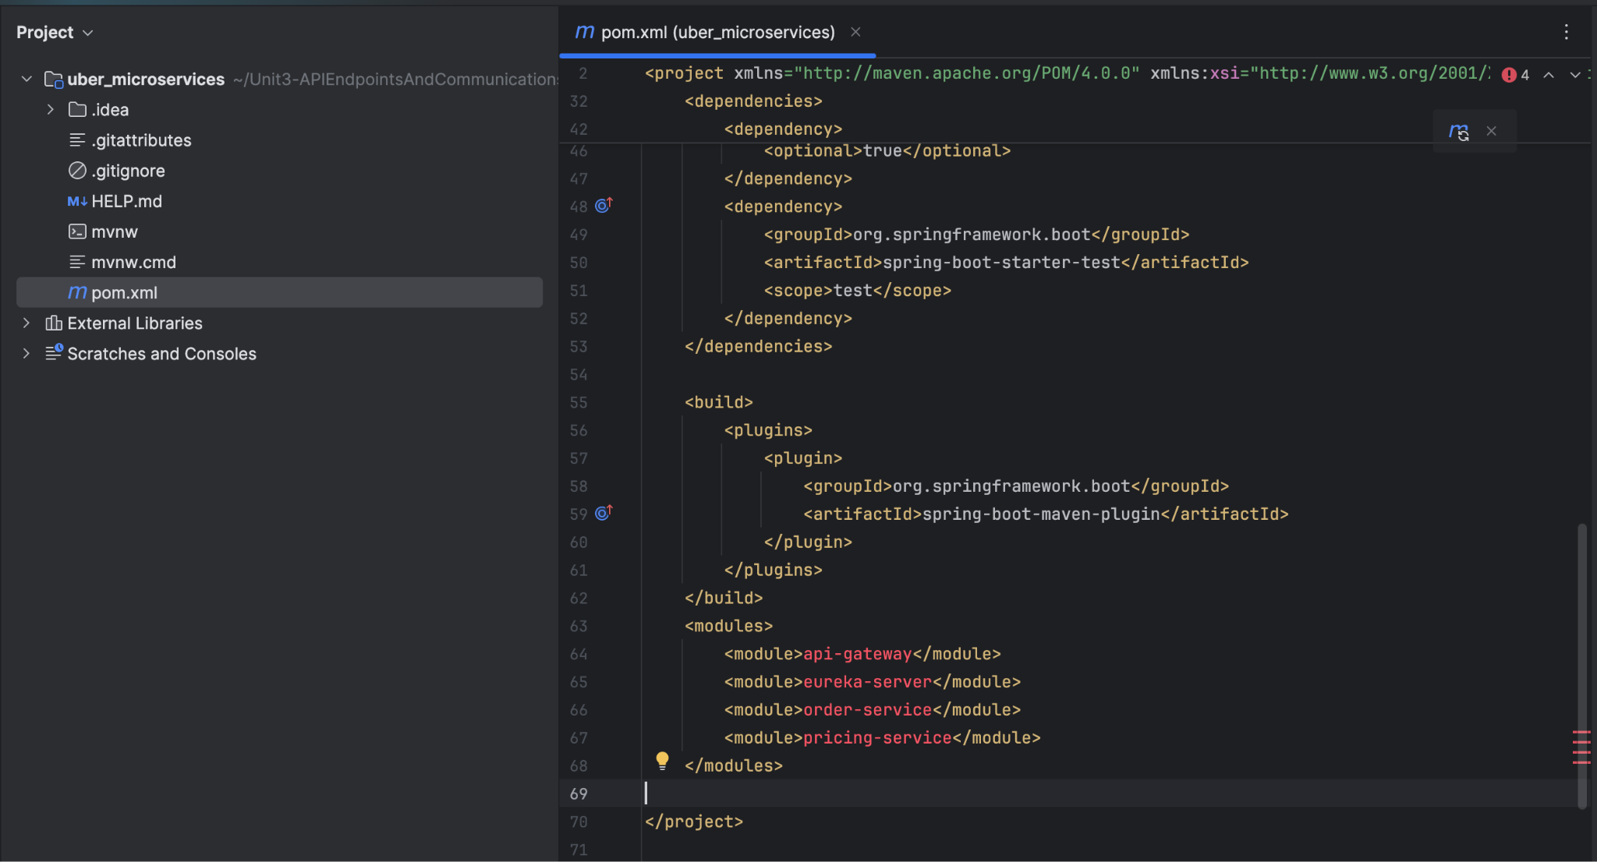

## Step 6: Create microservices

1. In terminal, CD to the uber_microsevices folder under >> this folder “Unit3-APIEndpointsAndCommunications”
2. Build below all 4 microservices

### a. api-gateway microservices

spring init --dependencies=cloud-gateway,cloud-eureka,actuator \

--name=api-gateway --group-id=com.uber \

--artifact-id=api-gateway --build=maven api-gateway

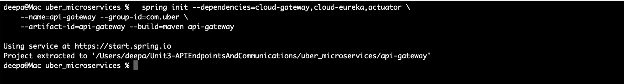

api-gateway >> turn from red to gray showing the dependency was successful as shown in the below screen. Also the respective folder gets created

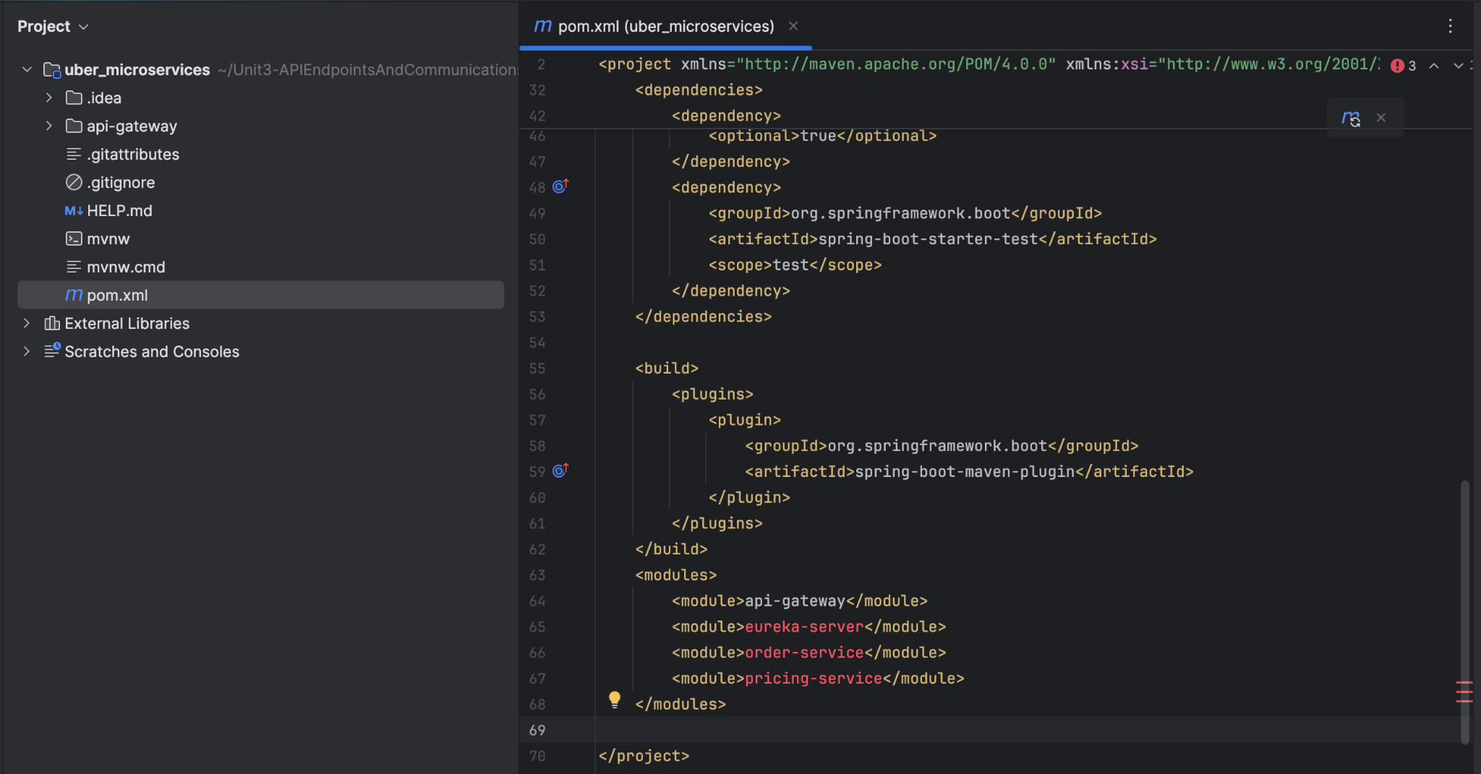

### b. eureka-server microservices

spring init --dependencies=cloud-eureka-server,actuator \

--name=eureka-server --group-id=com.uber \

--artifact-id=eureka-server --build=maven eureka-server

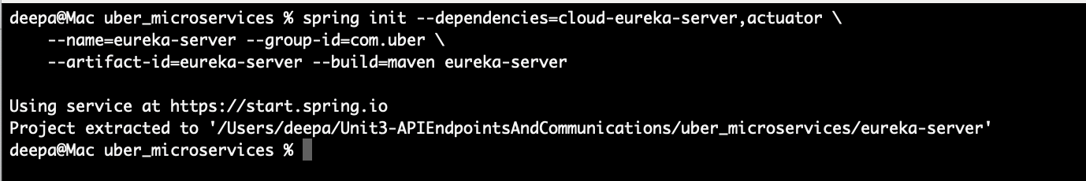

eureka-server >> turn from red to gray showing the dependency was successful as shown in the below screen. Also the respective folder gets created

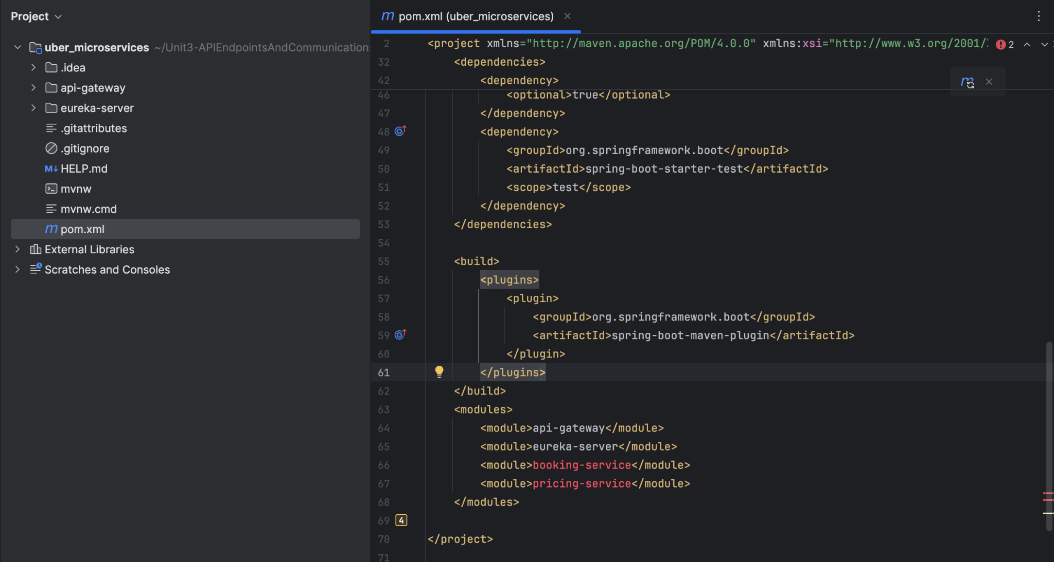

### c. booking-service microservices

spring init --dependencies=web,cloud-eureka,actuator,validation \

--name=booking-service --group-id=com.uber \

--artifact-id=booking-service --build=maven booking-service

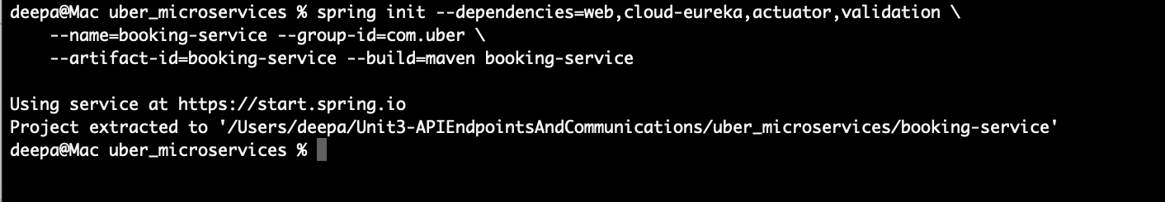

booking-service >> turn from red to gray showing the dependency was successful as shown in the below screen. Also the respective folder gets created

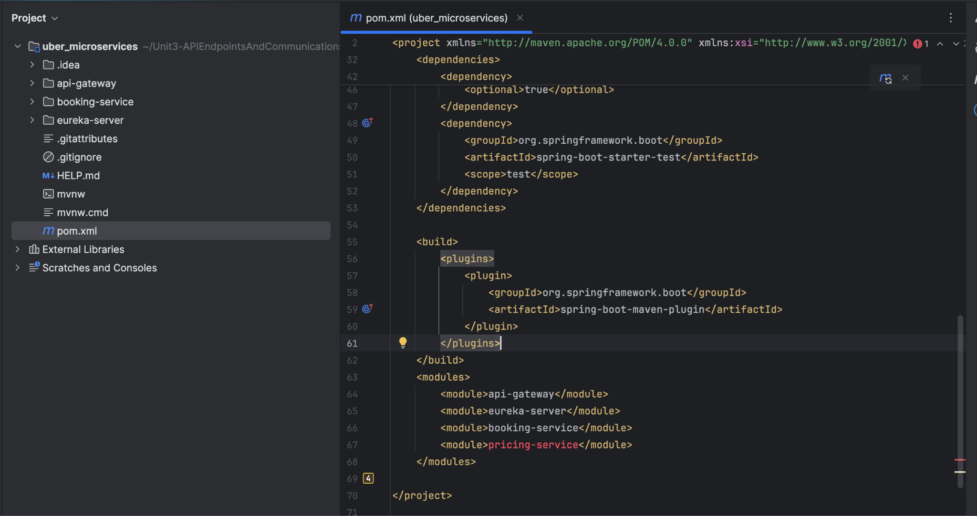

### d. pricing-service microservices

spring init --dependencies=web,cloud-eureka,actuator \

--name=pricing-service --group-id=com.restaurant \

--artifact-id=pricing-service --build=maven pricing-service

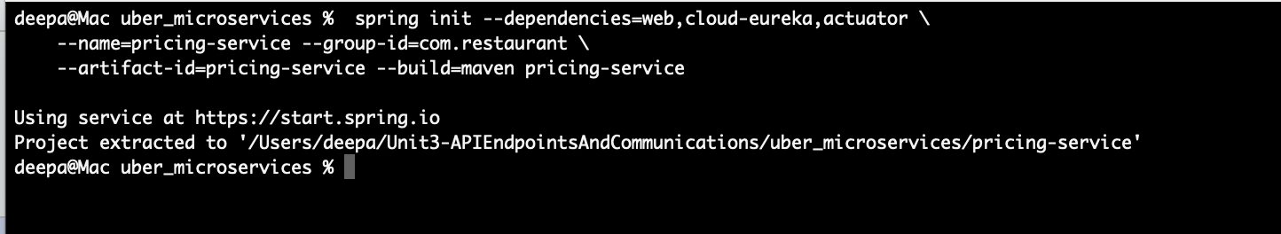

pricing-service >> turn from red to gray showing the dependency was successful as shown in the below screen. Also the respective folder gets created

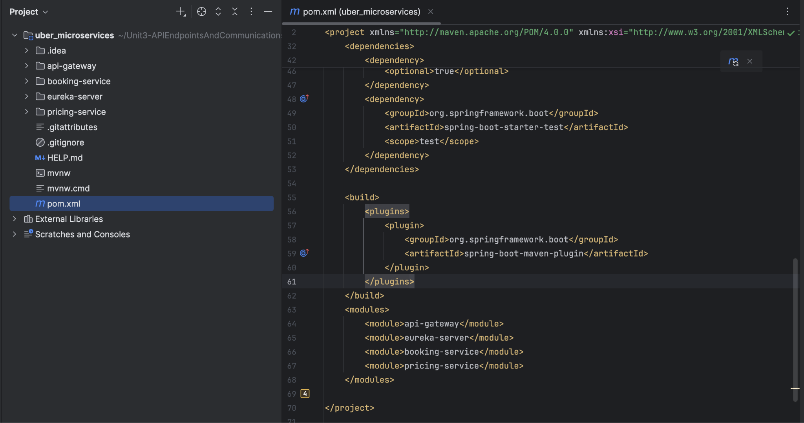

## Step 7: Build api-gateway folder and files

**Note:**

* ApiGatewayApplication is just prints the lines, and no business logic
* application.yml is the one which holds the business logic for ApiGatewayApplication

**How Services Connects:**

The connection between Booking Service and Pricing Service follows this flow:

Client Request → Booking Service → Pricing Service → Order Service → Client Response

1. Client sends an order request to Order Service
2. Booking Service extracts order details and calls Pricing Service
3. Pricing Service calculates the price and returns it
4. Booking Service creates the final order with the calculated price
5. Booking Service returns the complete order to the client

Steps to follow in api-gateway folder:

1. Remove “.mvn” folder in api-gateway folder

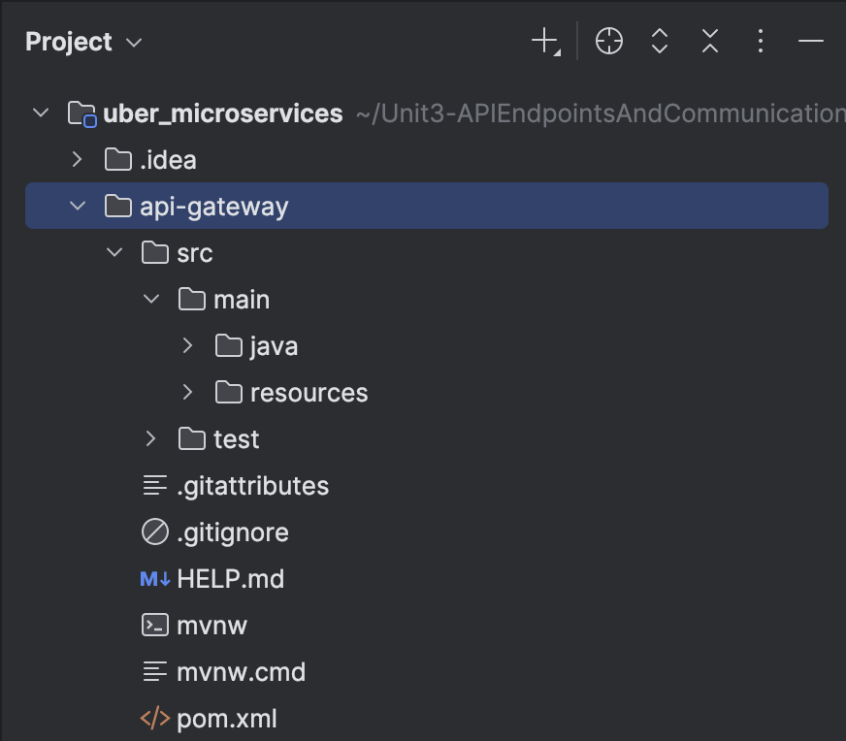

1. Expand resources and remove “application.properties” and add application.yml folder

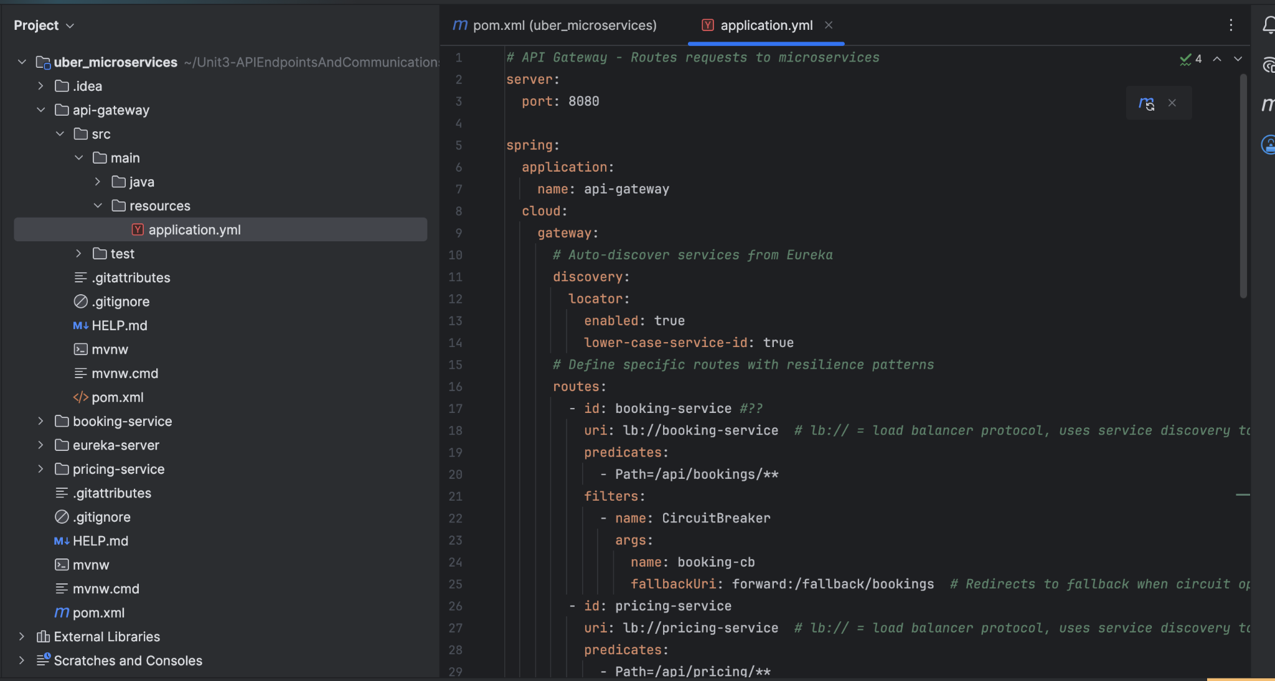

1. Expand java remove api_gateway folder with ApiGatewayApplication.java folder.

**Note:** ApiGatewayApplication is just prints the lines, and no business logic, 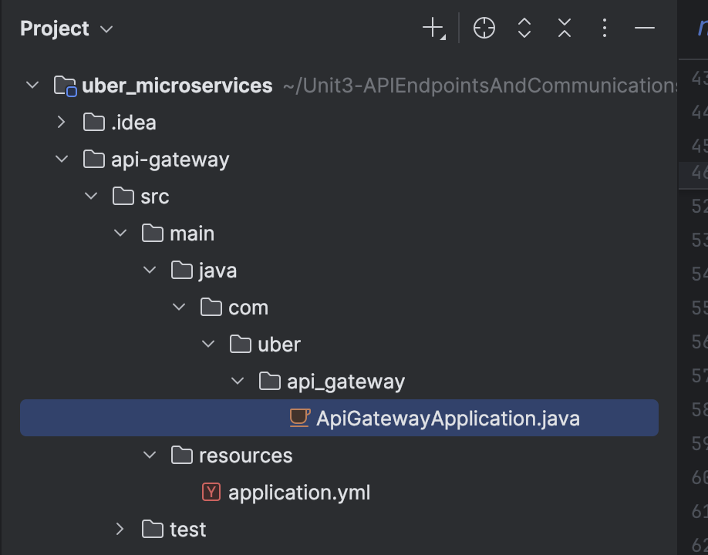

1. In api-gateway > Java folder > Add config folder, controller folder, and ApiGatewayApplication.java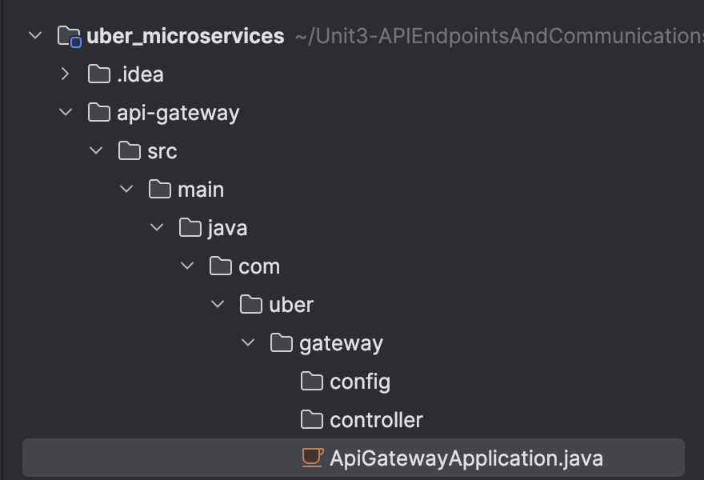
2. Expand the config file and add CorsConfig.java

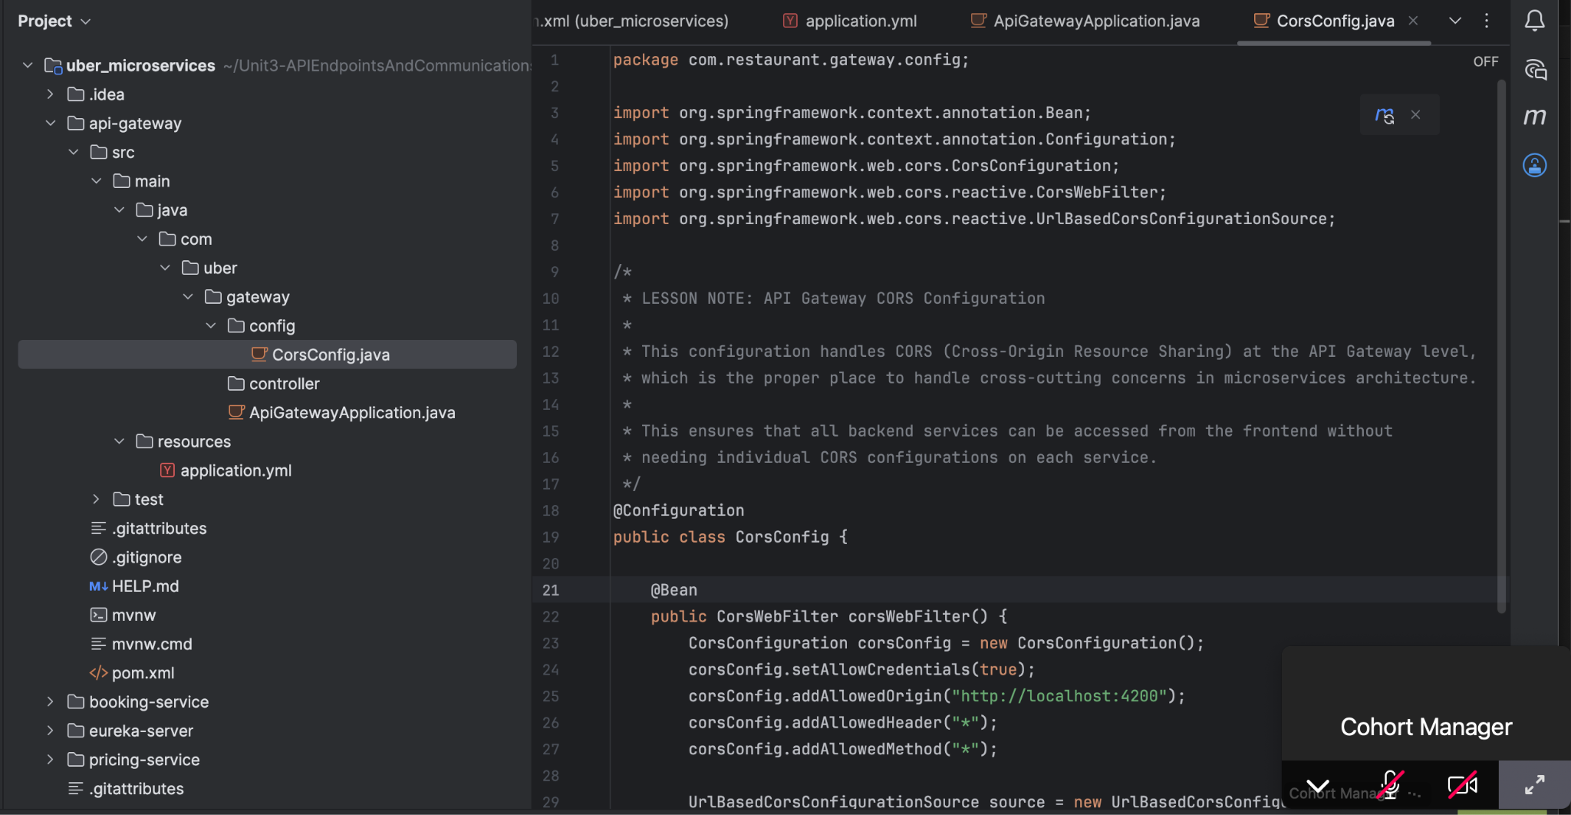

1. Expand controller folder and FallbackController.java

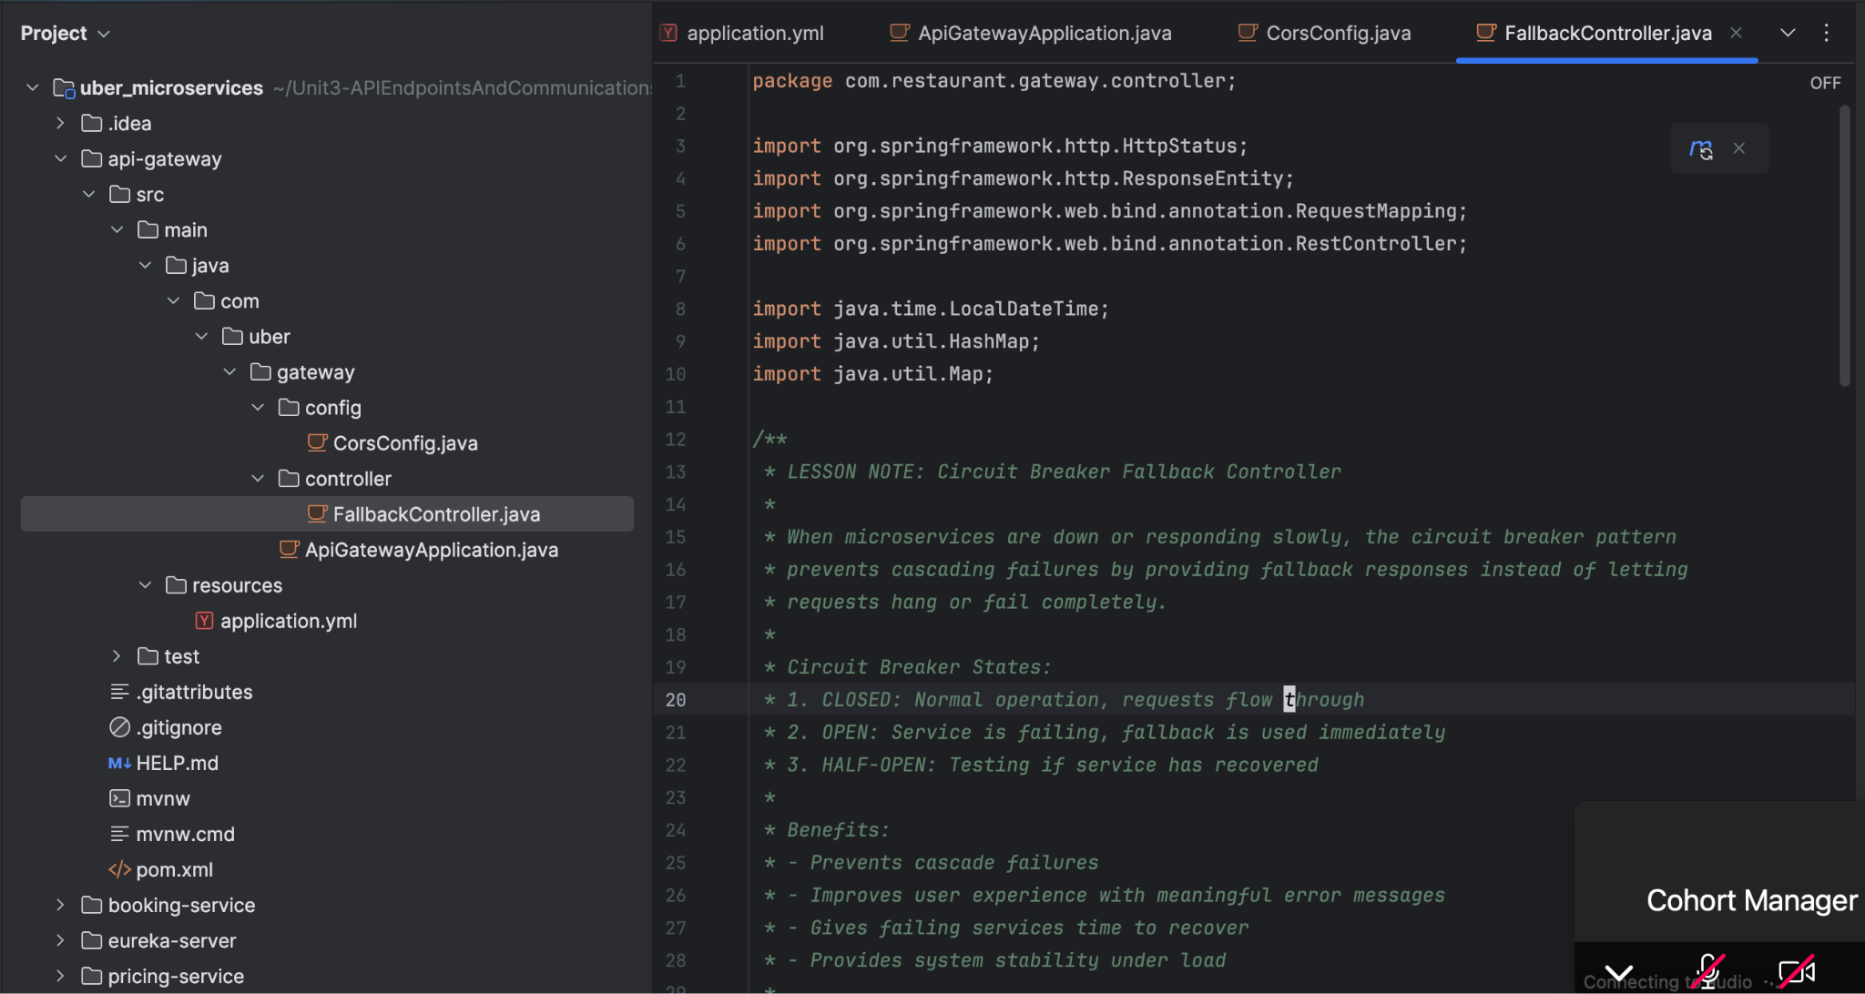

1. Add code in ApiGatewayApplication.java to print the lines:

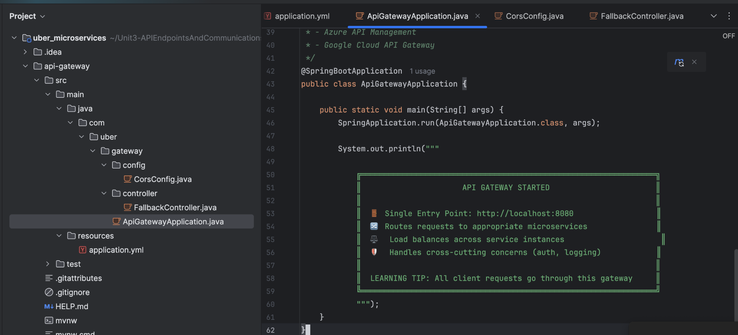

## Step 8: Build eureka-server:

* Remove .mvn folder
* Remove the existing default application.properties file under resource and create a new application.yml file. Defining the port : 8761

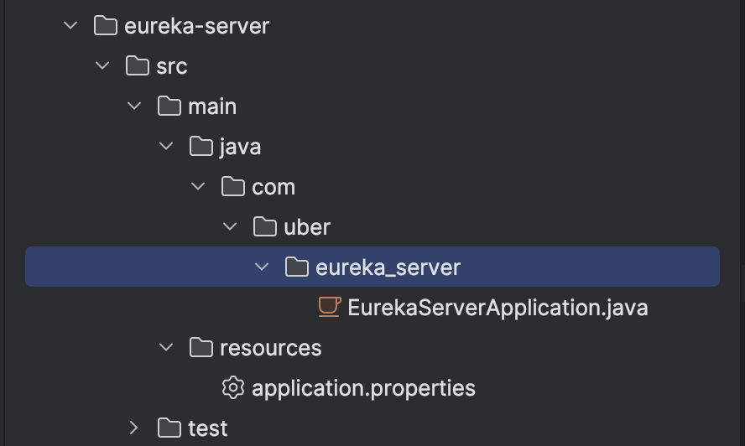

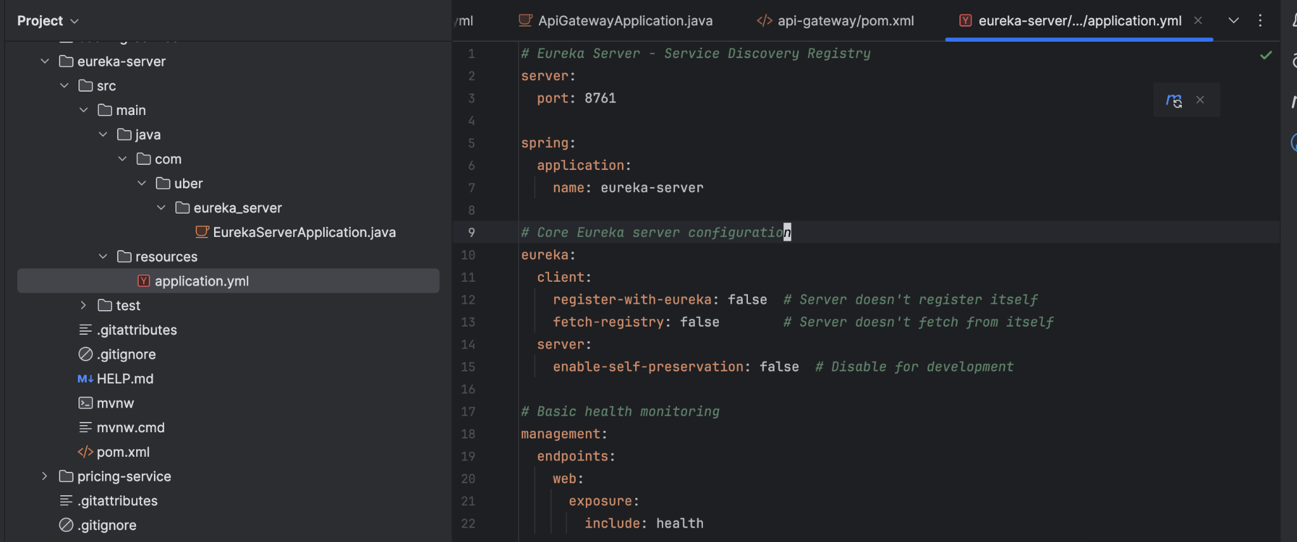

* Rename the eureka_server to eureka and add code in EurekaServerApplication to print the message

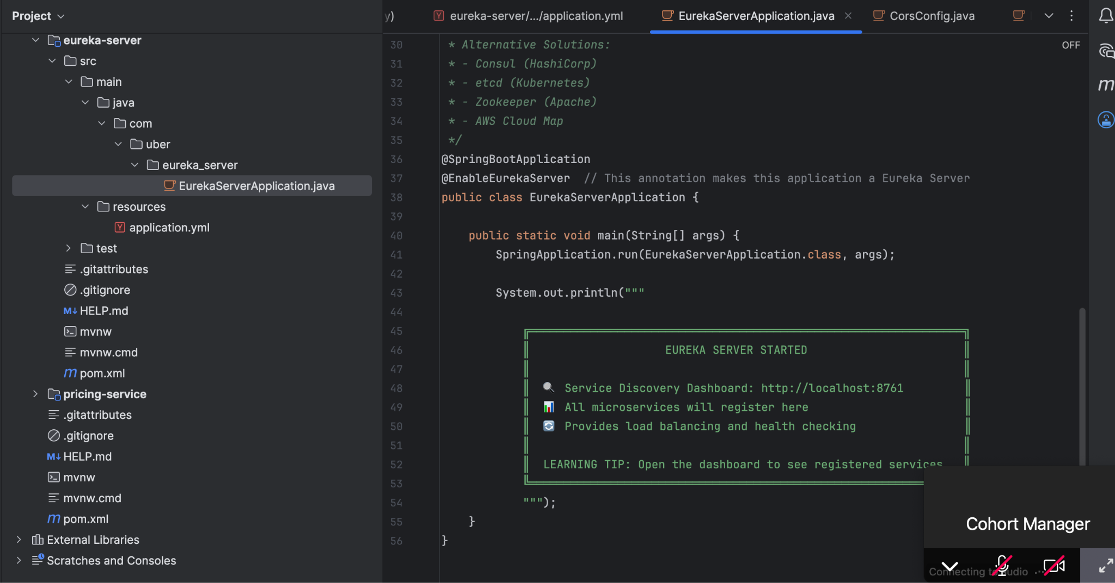

QUICK START:

### Startup Order (Important!)

1. Start Eureka Server (must be first) - 8761

cd eureka-server

mvn spring-boot:run

1. Start API Gateway (second) - 8080

cd api-gateway

mvn spring-boot:run

Eureka Server up and running:

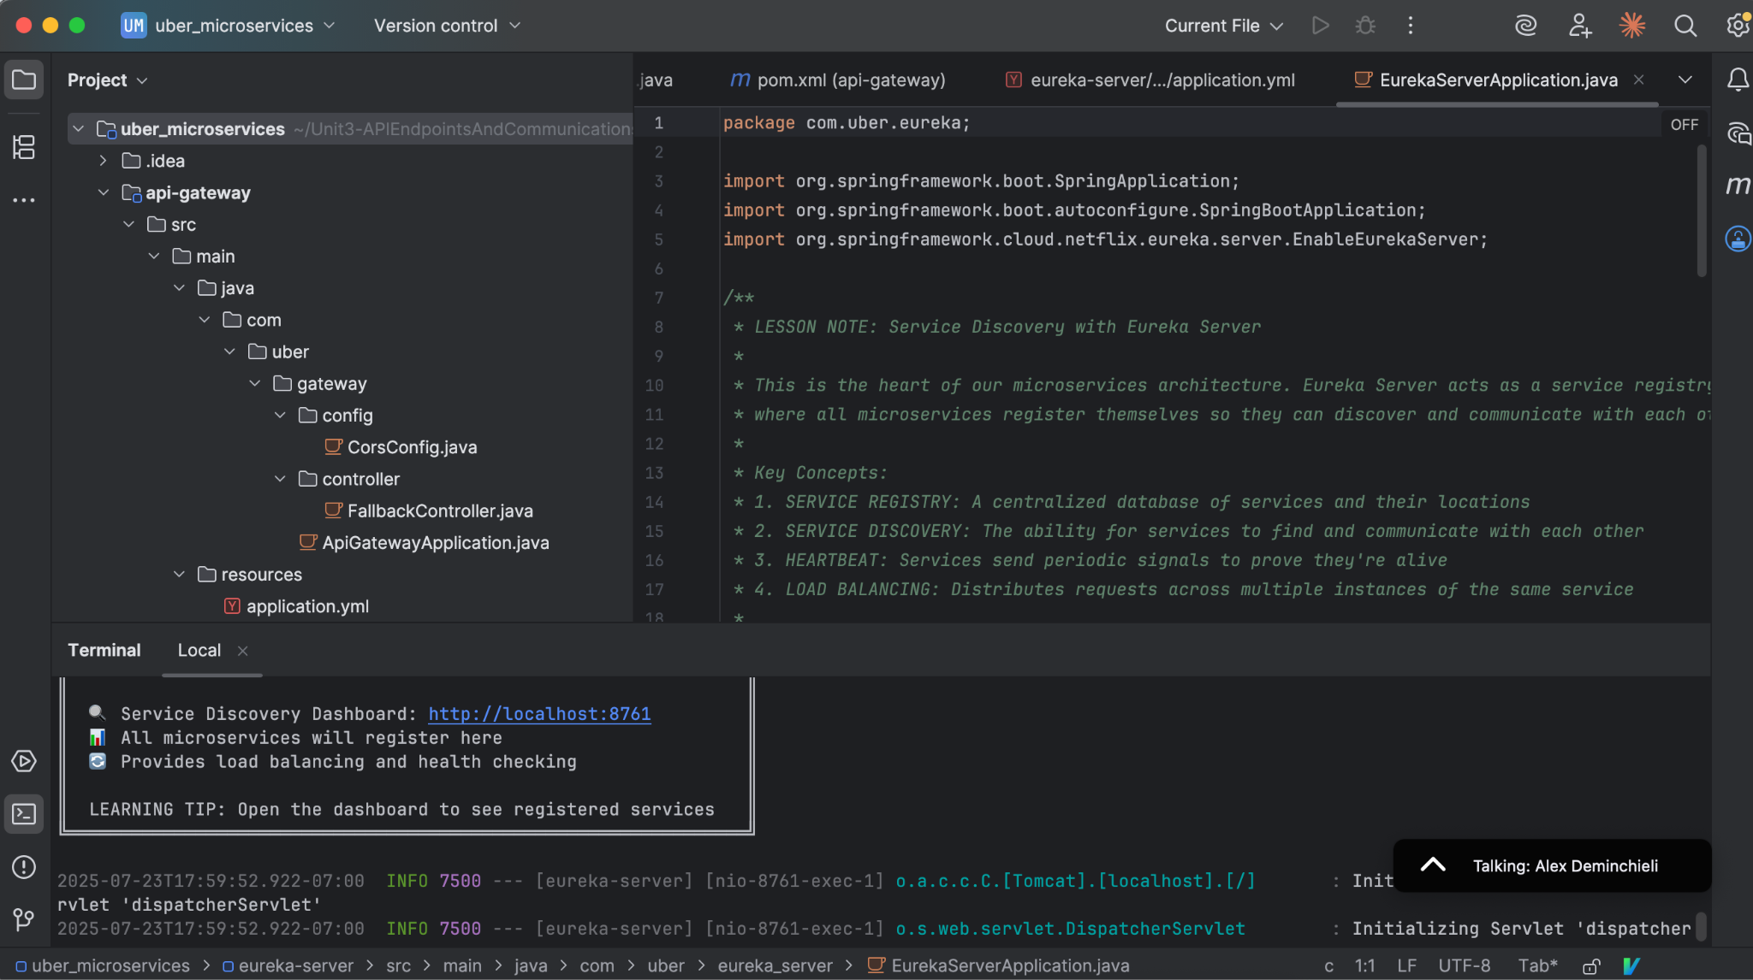

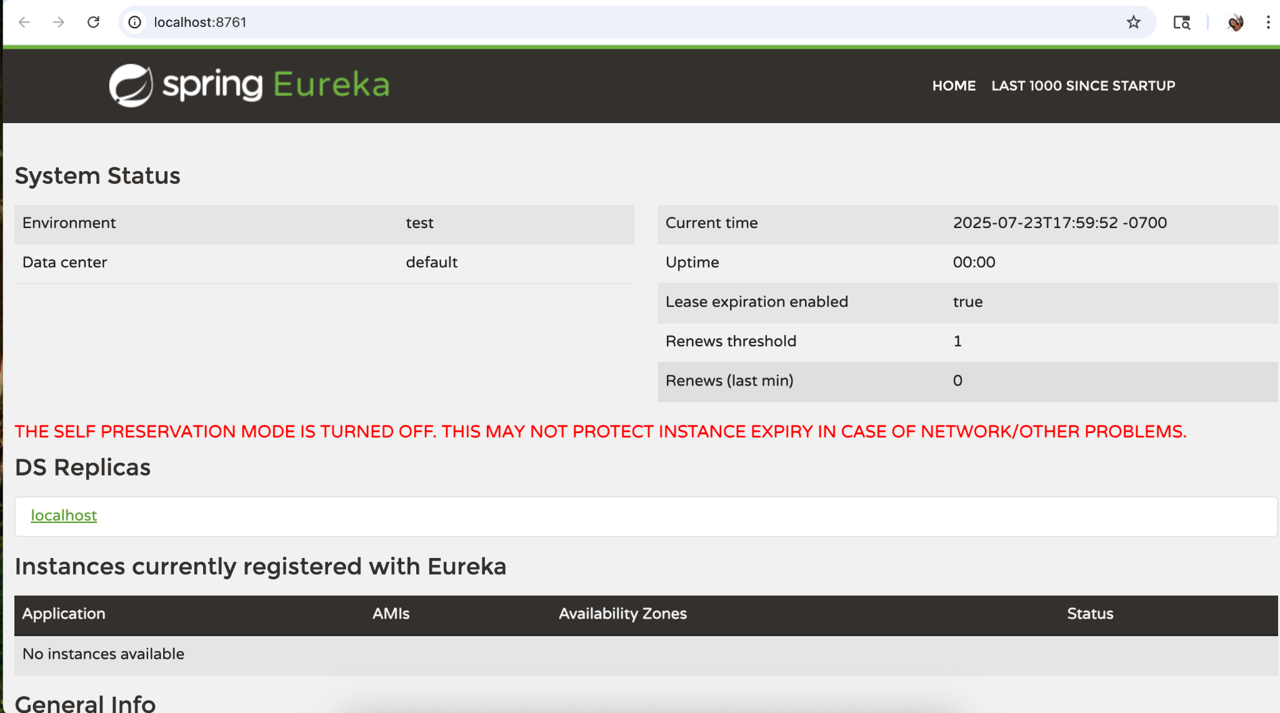

API Gateway Started:

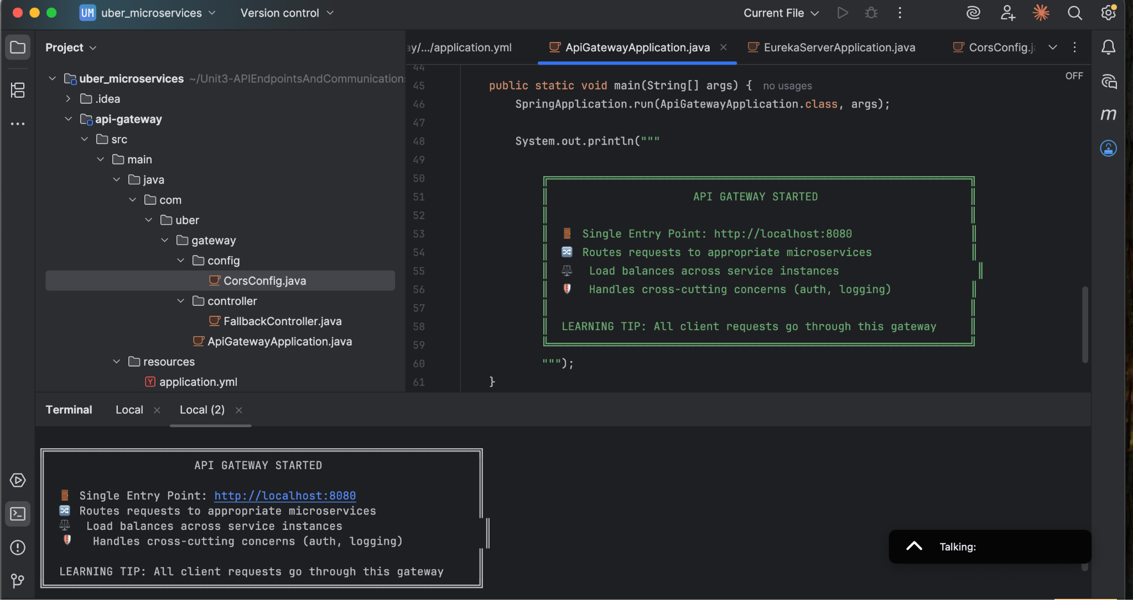

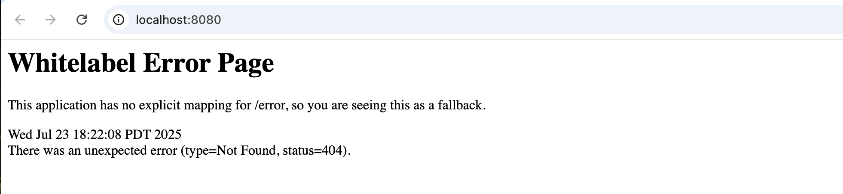

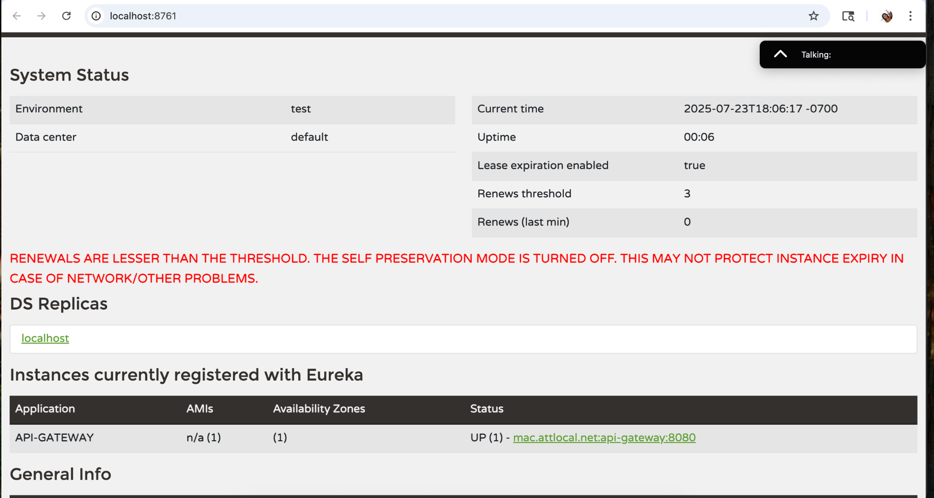

## Step 9: Building booking-service microservices

### Start Business Services (any order)

cd booking-service

mvn spring-boot:run

cd pricing-service

mvn spring-boot:run

**booking-service package >> .mvn directory**

1. Under booking-service package >> Remove .mvn directory

**booking-service package >> Under resources folder**

2. Under booking-service package >> Under resources, delete static folder, templates folder, application.properties

3. Under booking-service package >> Under resources, add

* application.yml file
* db/migration folder
  + V1__Create_orders_table.sql

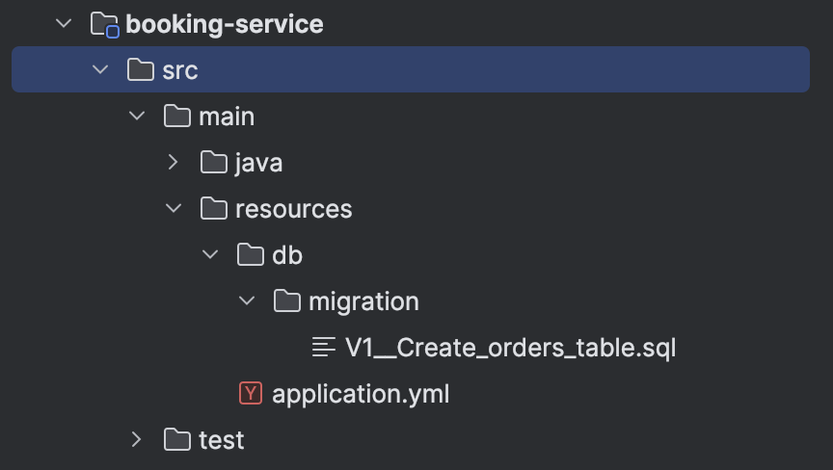

**Add code in the application.yml file:**

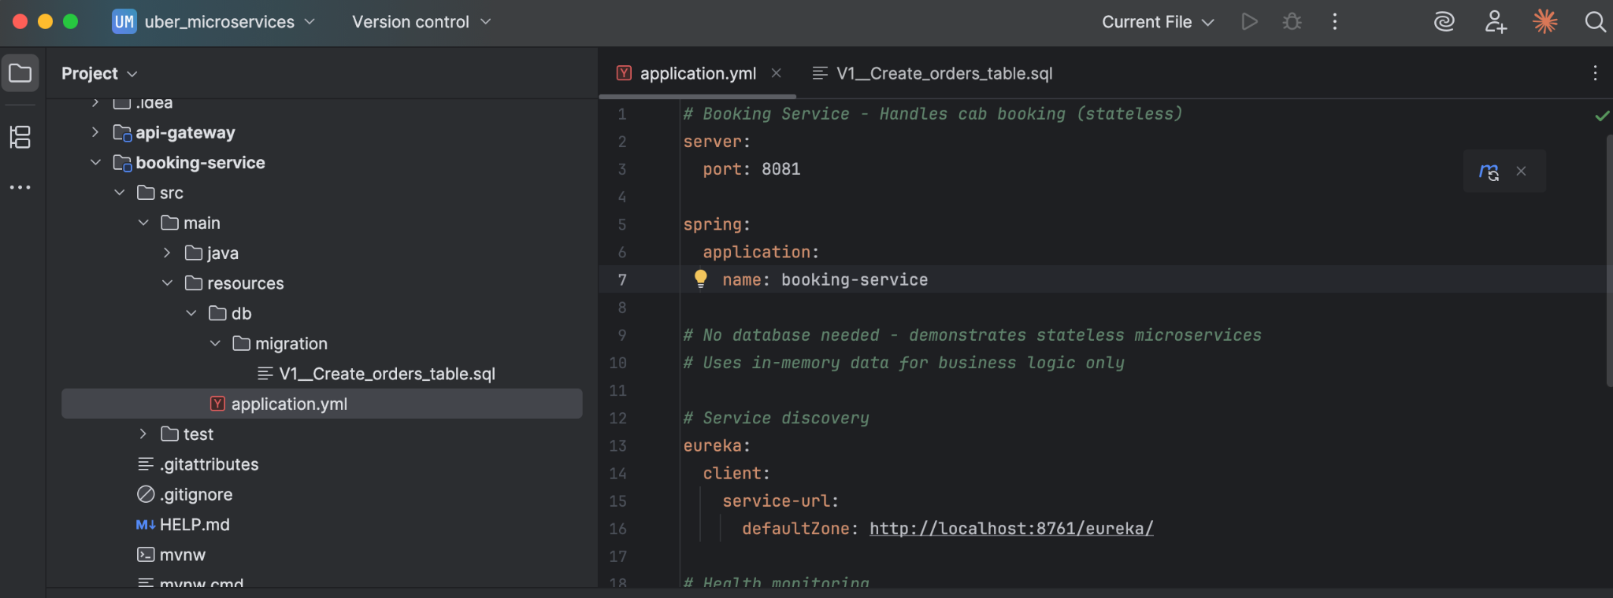

**Add code in the V1__Create_orders_table.sql:**

-- Create the main booking table

CREATE TABLE IF NOT EXISTS bookings (

id INTEGER PRIMARY KEY AUTOINCREMENT,

customer_name VARCHAR(255) NOT NULL,

city TEXT NOT NULL,

number_of_people INTEGER NOT NULL,

total_amount DECIMAL(10,2) NOT NULL,

status VARCHAR(50) NOT NULL,

);

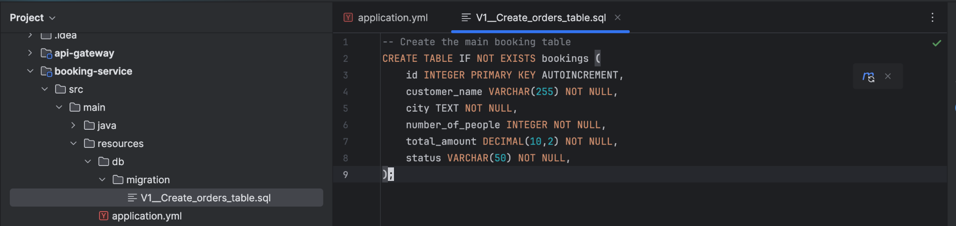

**booking-service package >> src > main > java > com > uber**

* **Add booking folder**
* **Remove booking_service folder**

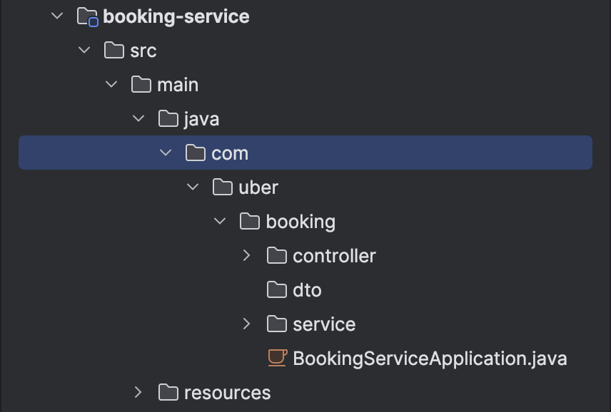

1. **Add controller, dto, service folders and BookingServiceApplication.java**

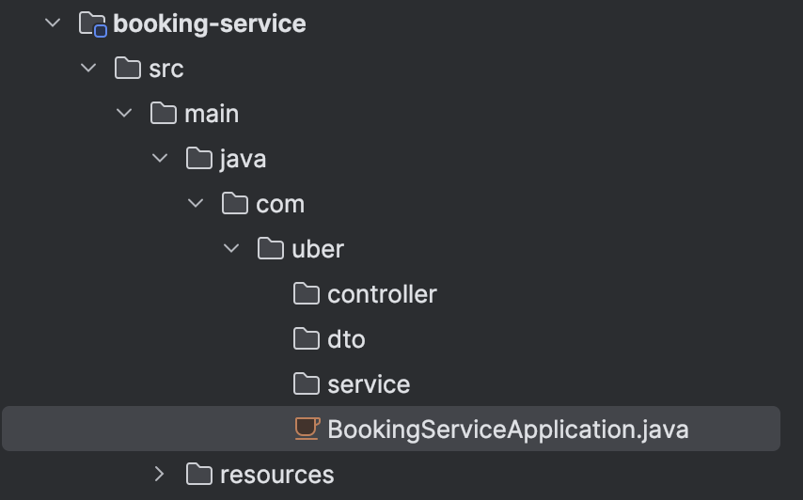

1. **Add code under, booking-service package >> src > main > java > com > uber > booking > BookingServiceApplication.java**

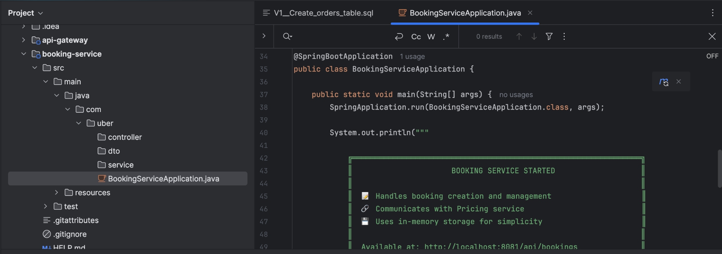

1. **Create BookingController.java under controller folder and add code to the java file:**

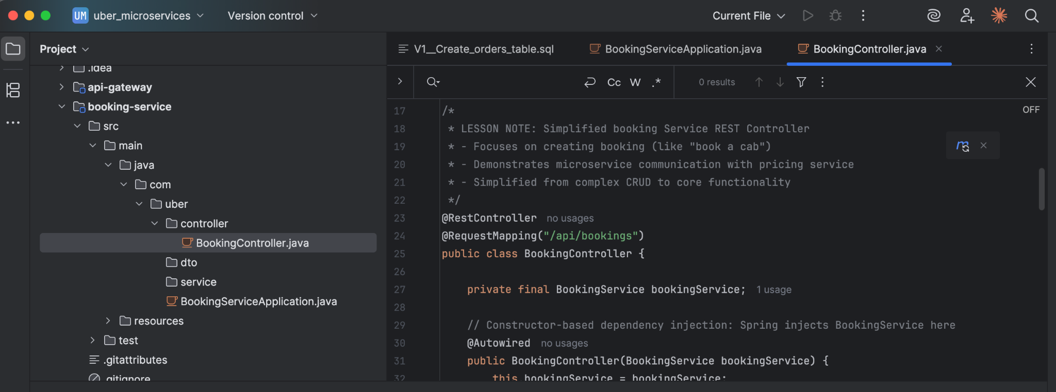

1. **Create BookingService.java under service folder and add code to the java file:**

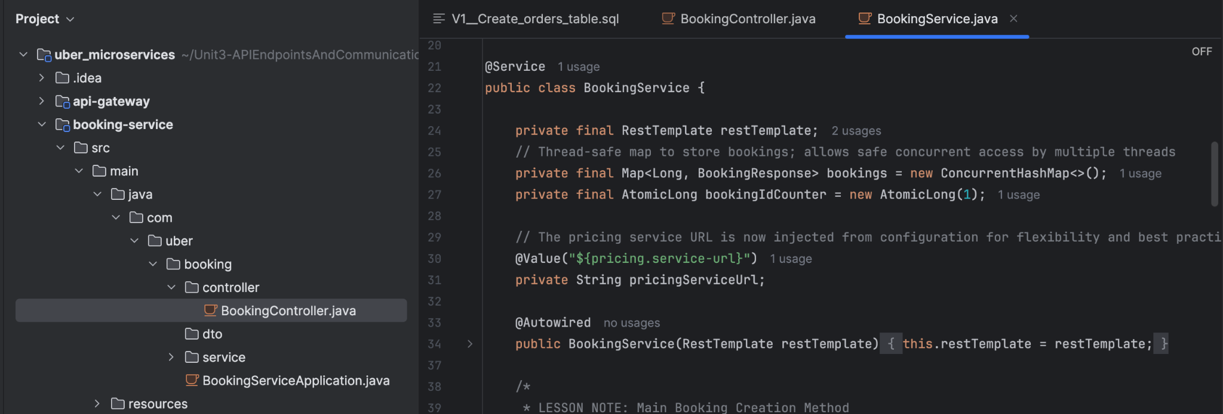

**booking-service package >> DTO**

1. **Add code under, booking-service package >> src > main > java > com > uber > DTO folder — Create below java files**
   1. **BookingPricingRequest.java**
   2. **BookingRequest.java**
   3. **BookingResponse.java**
   4. **PricingResponse.java**

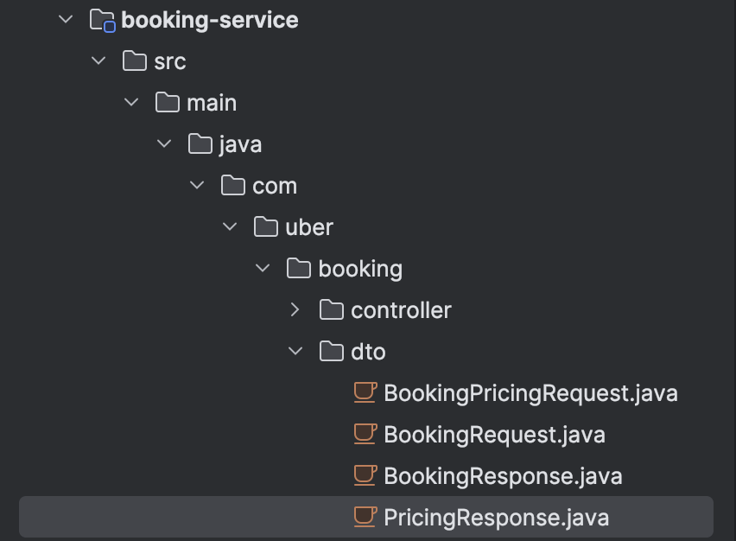

1. **Add code in BookingRequest.java**

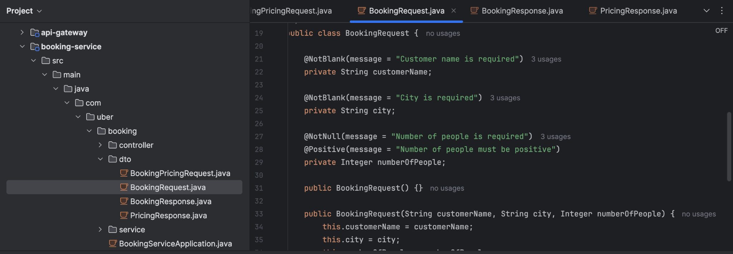

1. **Add code in BookingResponse.java**

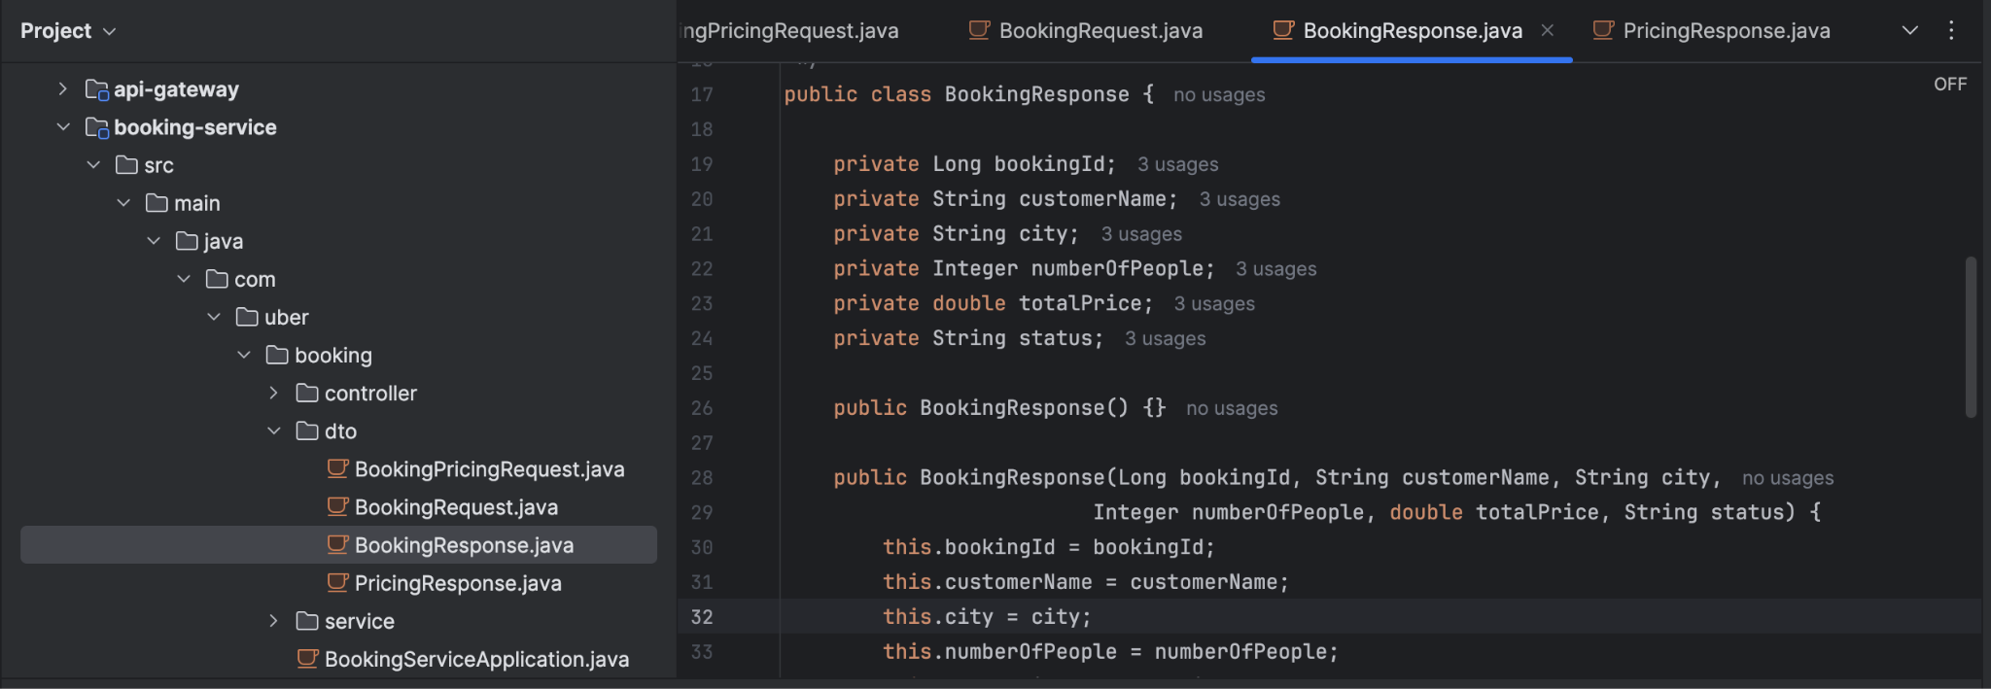

1. **Add code in PricingResponse.java**

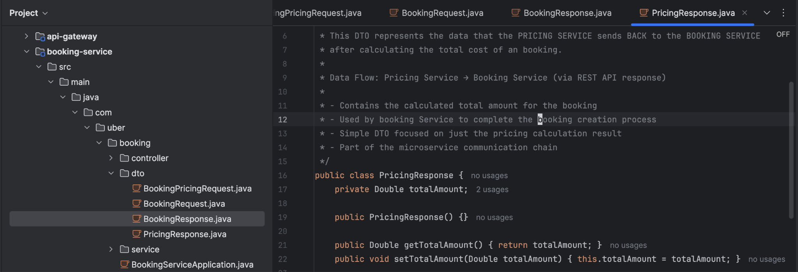

1. **Add code in BookingPricingRequest.java**

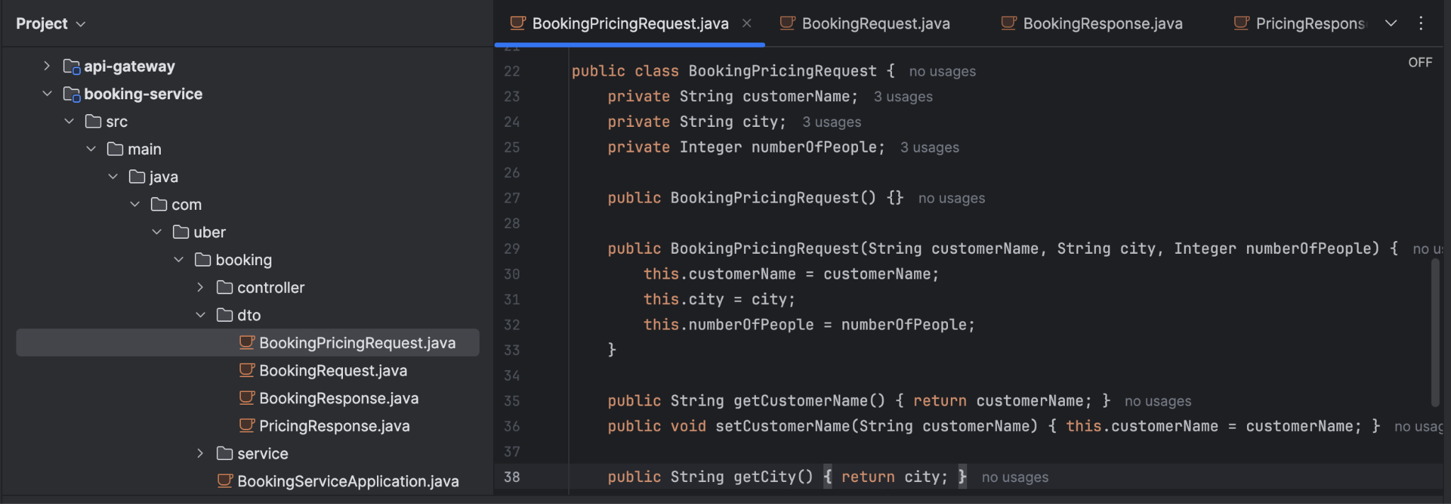

## Step 10: Building pricing-service microservices

1. In pricing-service folder >> Delete .mvn folder
2. In pricing-service folder, src > main > resources
   1. delete static and templates folder
   2. Delete applications.properties
3. In pricing-service folder, src > main > resources
   1. Add application.yml file and add code

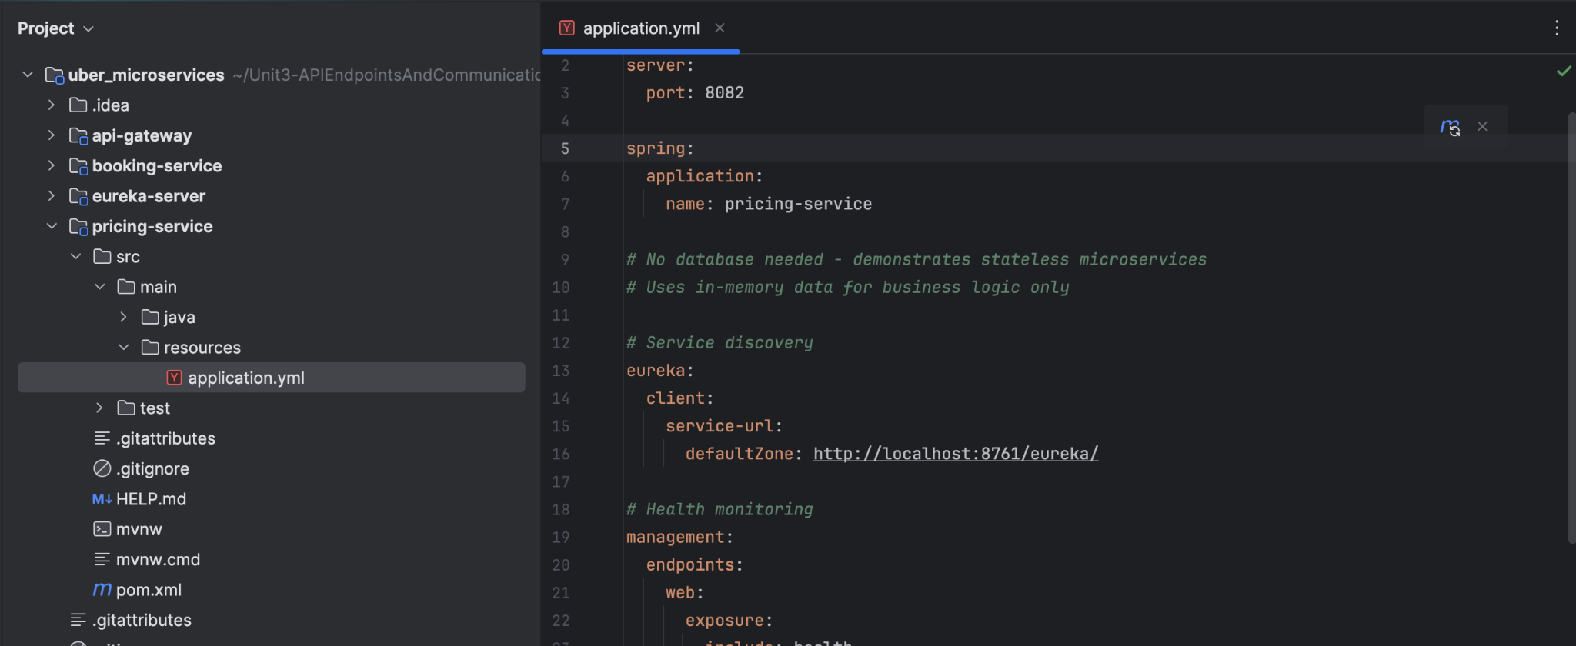

1. Under pricing-service > src > main > java > com > uber
   1. Remove pricing_service folder
2. Under pricing-service > src > main > java > com > uber > pricing
   1. Add -> controller,
   2. dto,
   3. service folders and
   4. PricingServiceApplication.java
3. Add code in **PricingServiceApplication.java**

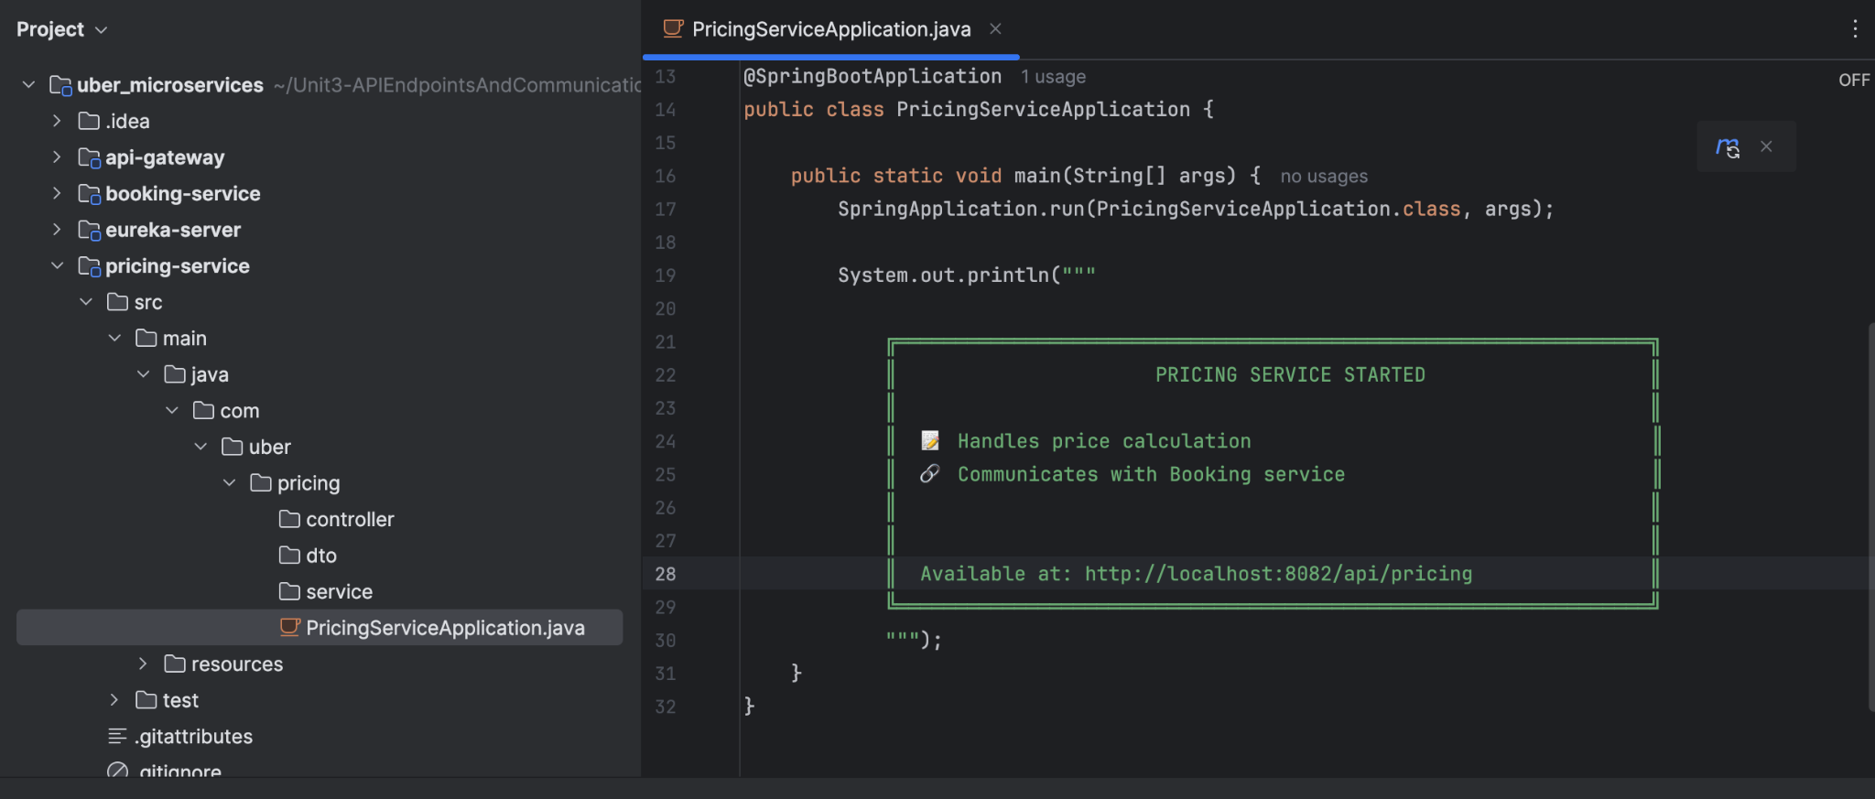

m) Add **PricingService.java** file and add code under **service** folder [pricing-service > src > main > java > com > uber > pricing > service]

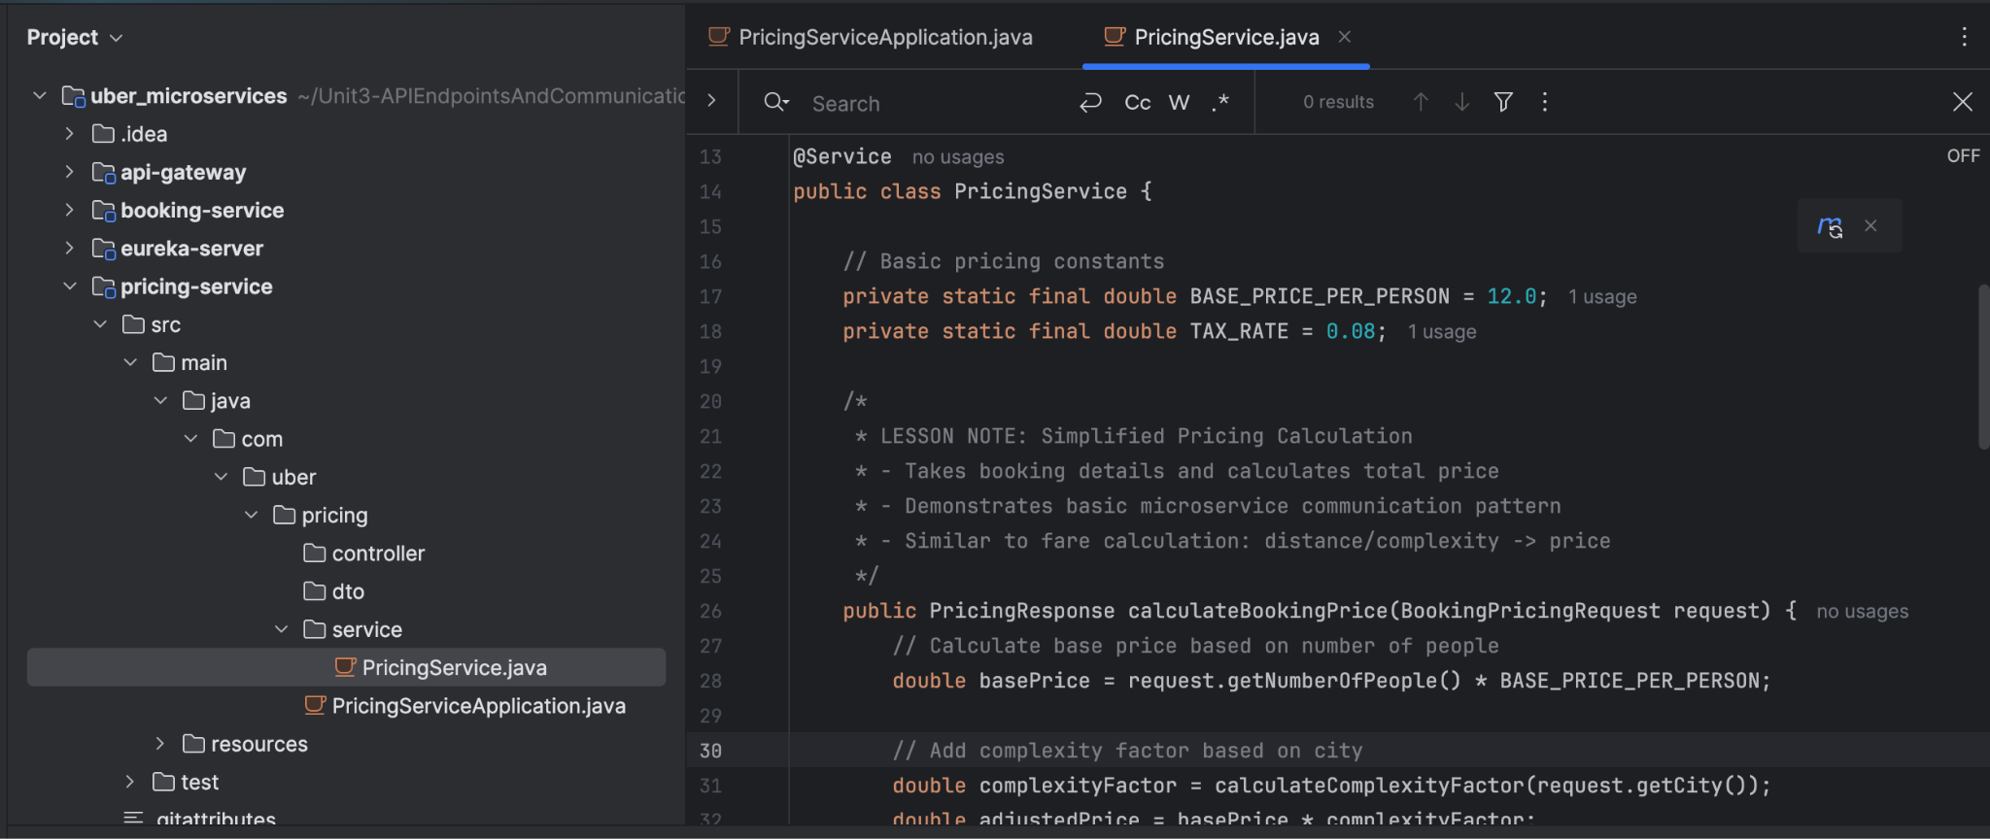

n) Add **PricingController.java** file and add code under **controller** folder [pricing-service > src > main > java > com > uber > pricing > controller]

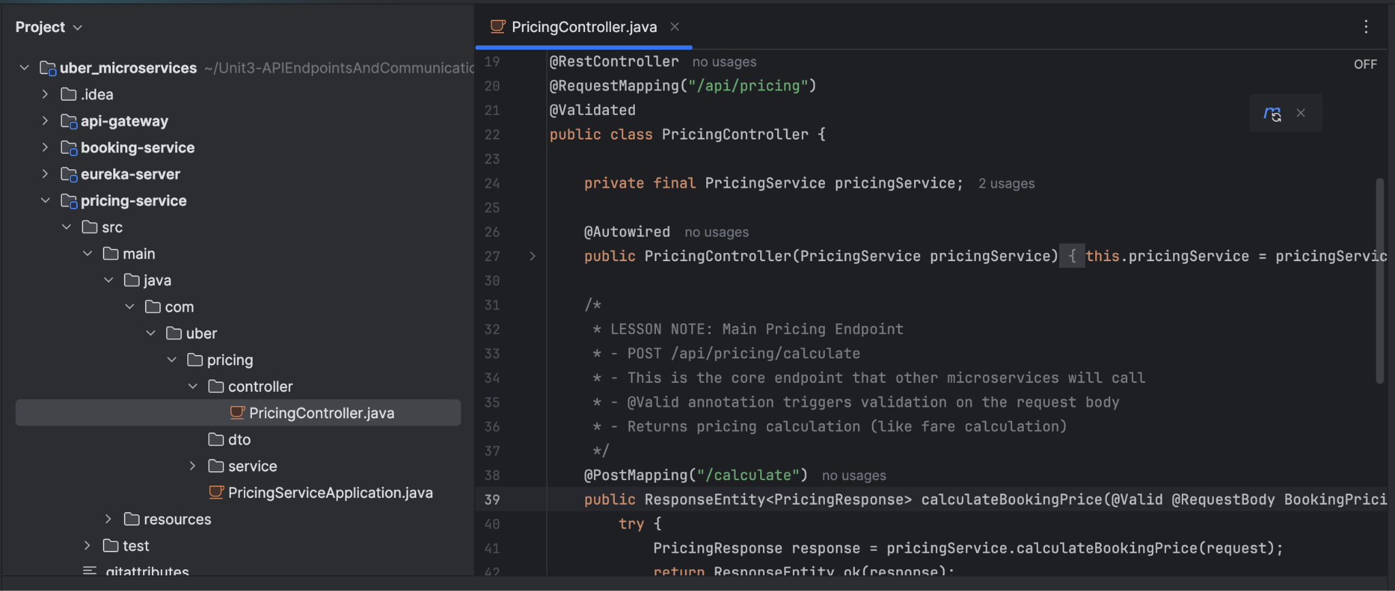

o) Under **dto** folder [pricing-service > src > main > java > com > uber > pricing > dto], add following java files

1. PricingResponse.java
2. BookingPricingResponse.java

p) Under PricingResponse.java add the below code

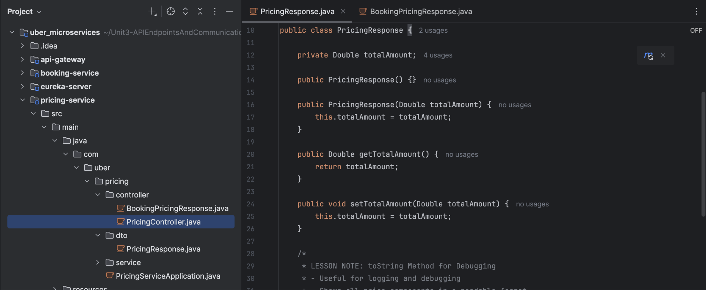

q) Under BookingPricingResponse.java add the below code

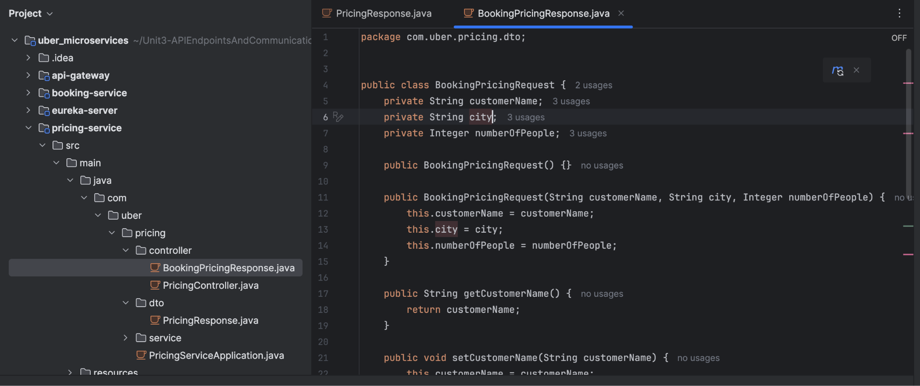

cd pricing-service

mvn spring-boot:run

## Step 11: Validate if this is working in postman

1. Download local postman on you mac
2. Post: http://localhost:8080/api/bookings

## Step 12: Frontend development using Angular

1. Navigate to **uber_microservice** capstone project in the **terminal**
2. Type “**ng new form**”
3. Leave defaults >> select CSS and enter ‘yes’ option.
4. Angular project will get installed successfully.
5. The **Angular project “form” package** is **created under** the **uber_microservice**.

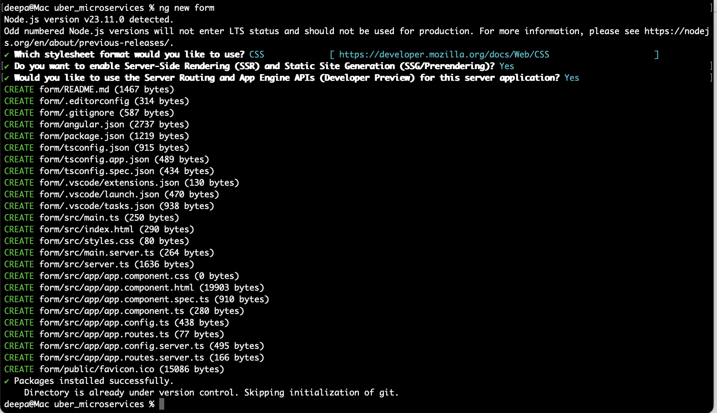

1. In IntelliJ, you will see the form folder under uber microservice. And add the frontend code in this Angular project to communicate with the backend microservices Booking-Services and Pricing-Services

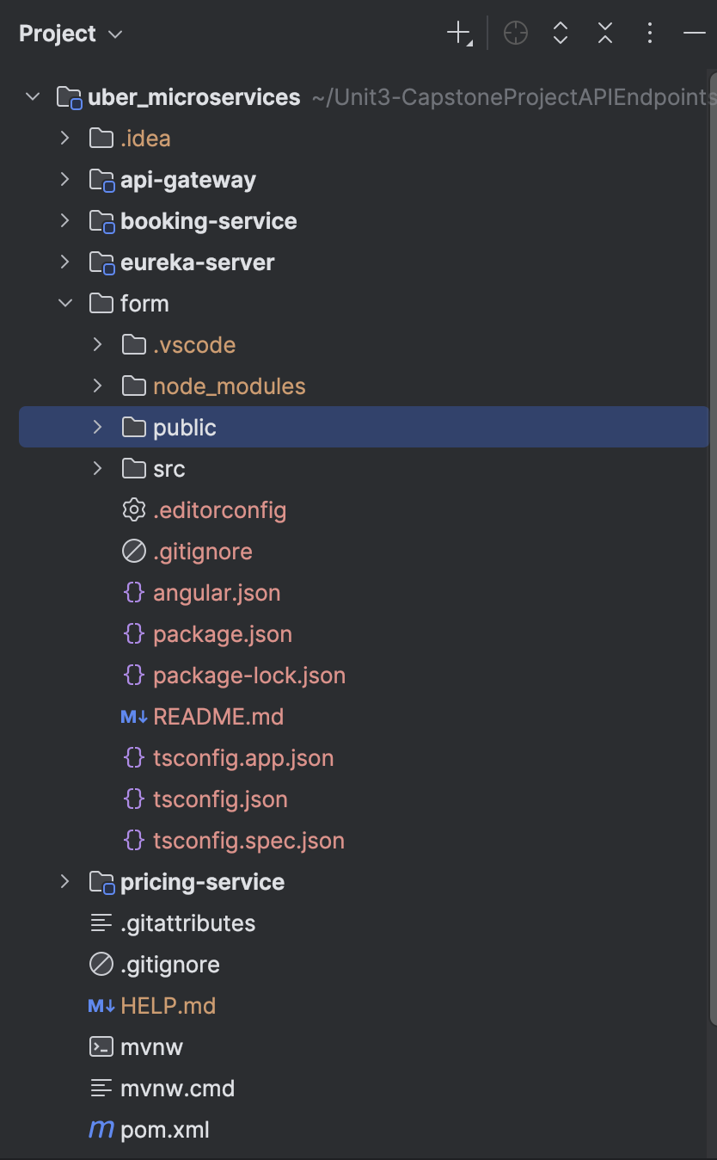

1. And under src these are the default folders that comes with this command **ng new form** >> package creation

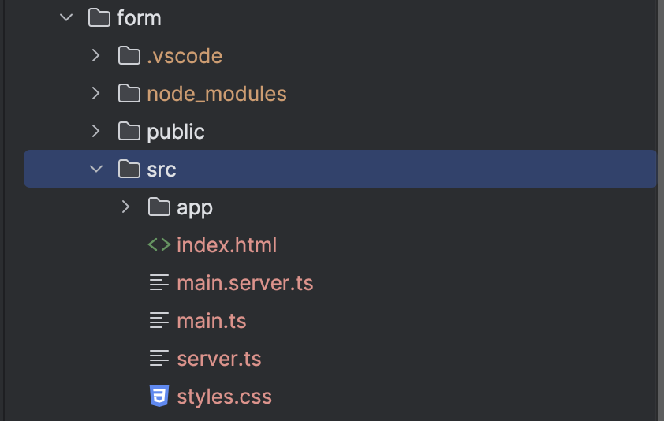

1. Open src >> app folder and here is the default folders and it’s structure

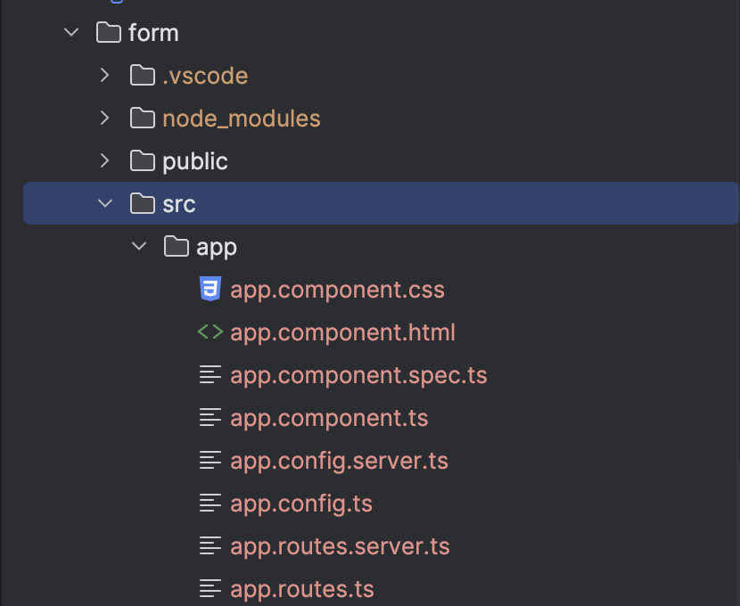

1. In the **IntellJ terminal**, cd to **form/src/app**
2. Type “**ng generate service booking**” which will create [booking.service.ts](http://booking.service.ts) and [booking.service.spec.ts](http://booking.service.spec.ts) files

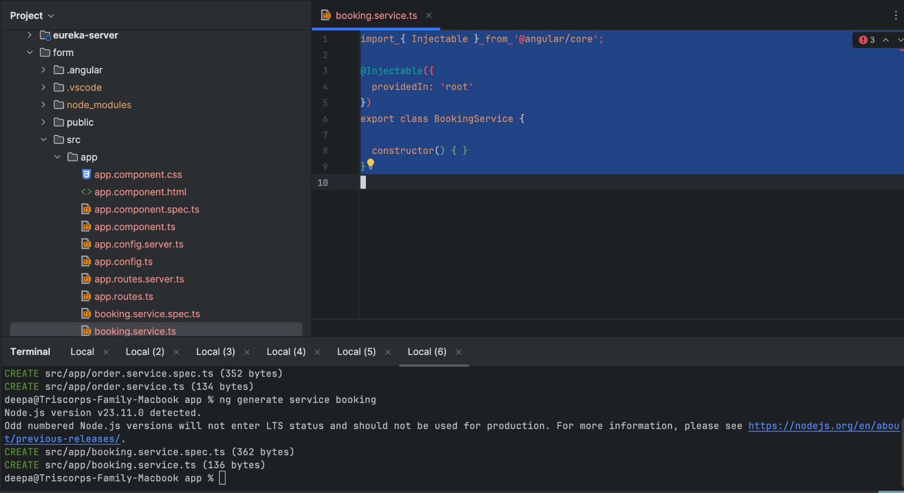

1. In [booking.service.ts](http://booking.service.ts) and add code [Need Api-gateway end point]

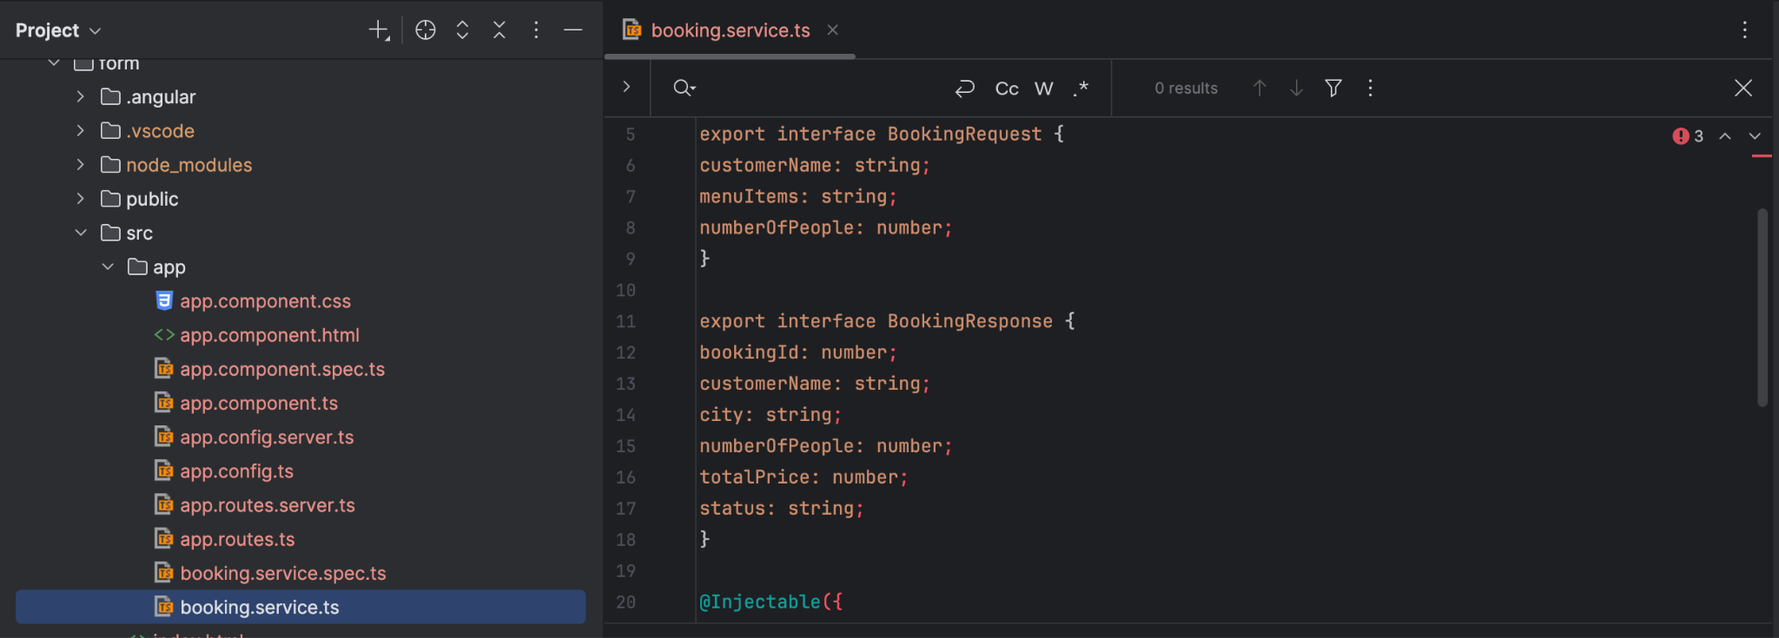

1. Navigate to [app.component.ts](http://app.component.ts) and view the default file details

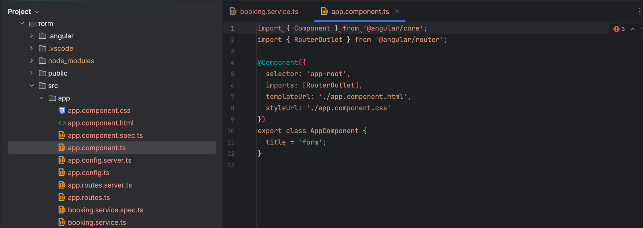

1. Navigate to [app.component.ts](http://app.component.ts) and modify import, Route, and build the function isFormValid()

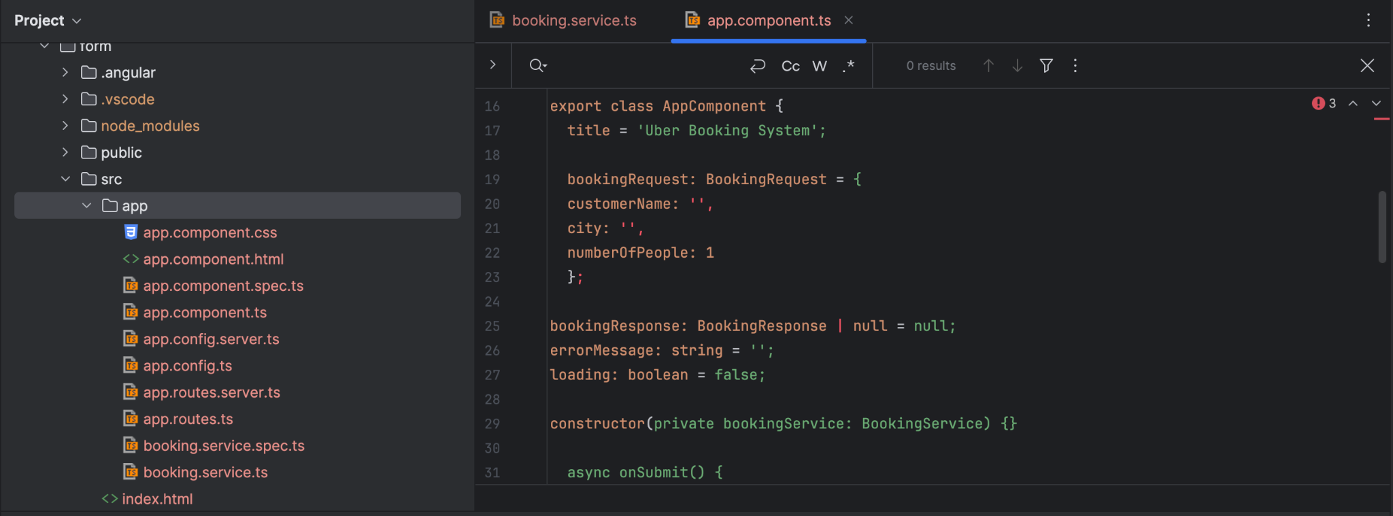

1. In **app.component.html** remove the default info and add more info related to the application

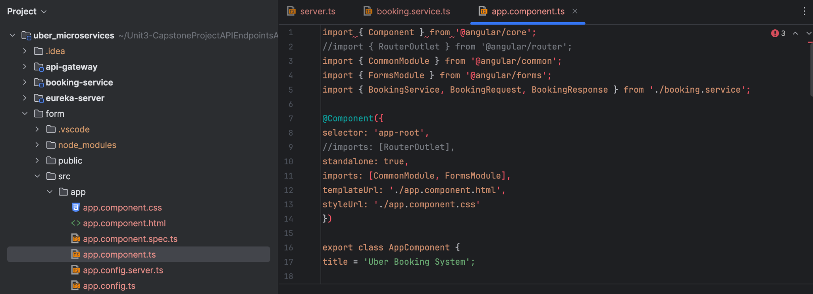

1. Navigate to app.component.html and add code related to booking

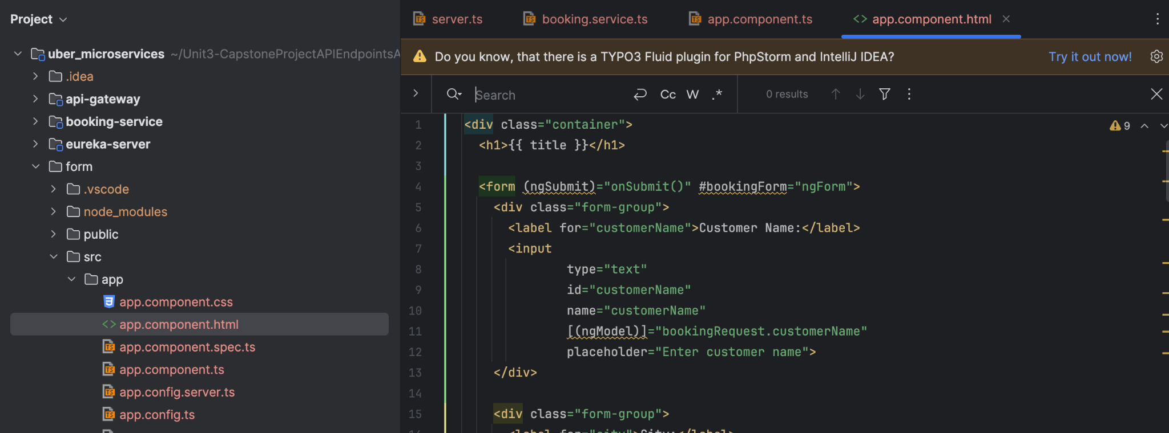

1. Navigate to app.component.css and add related styling sheet code

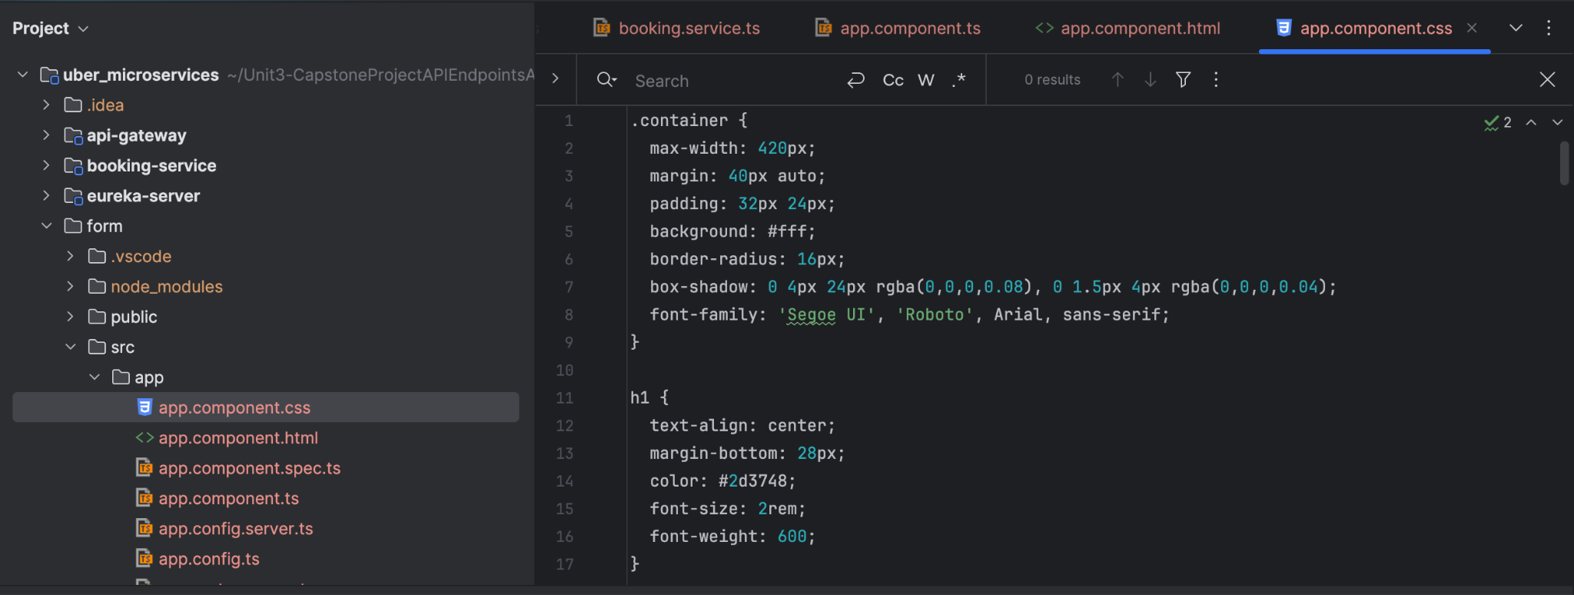

1. Update [app.config.js](http://app.config.js)

import { provideRouter } from '@angular/router';

import { provideHttpClient } from '@angular/common/http';

import { routes } from './app.routes';

import { provideClientHydration, withEventReplay } from '@angular/platform-browser';

export const appConfig = {

providers: [

provideRouter(routes),

provideClientHydration(withEventReplay()),

provideHttpClient()

]

};

1. Run an application and verify the program is working.

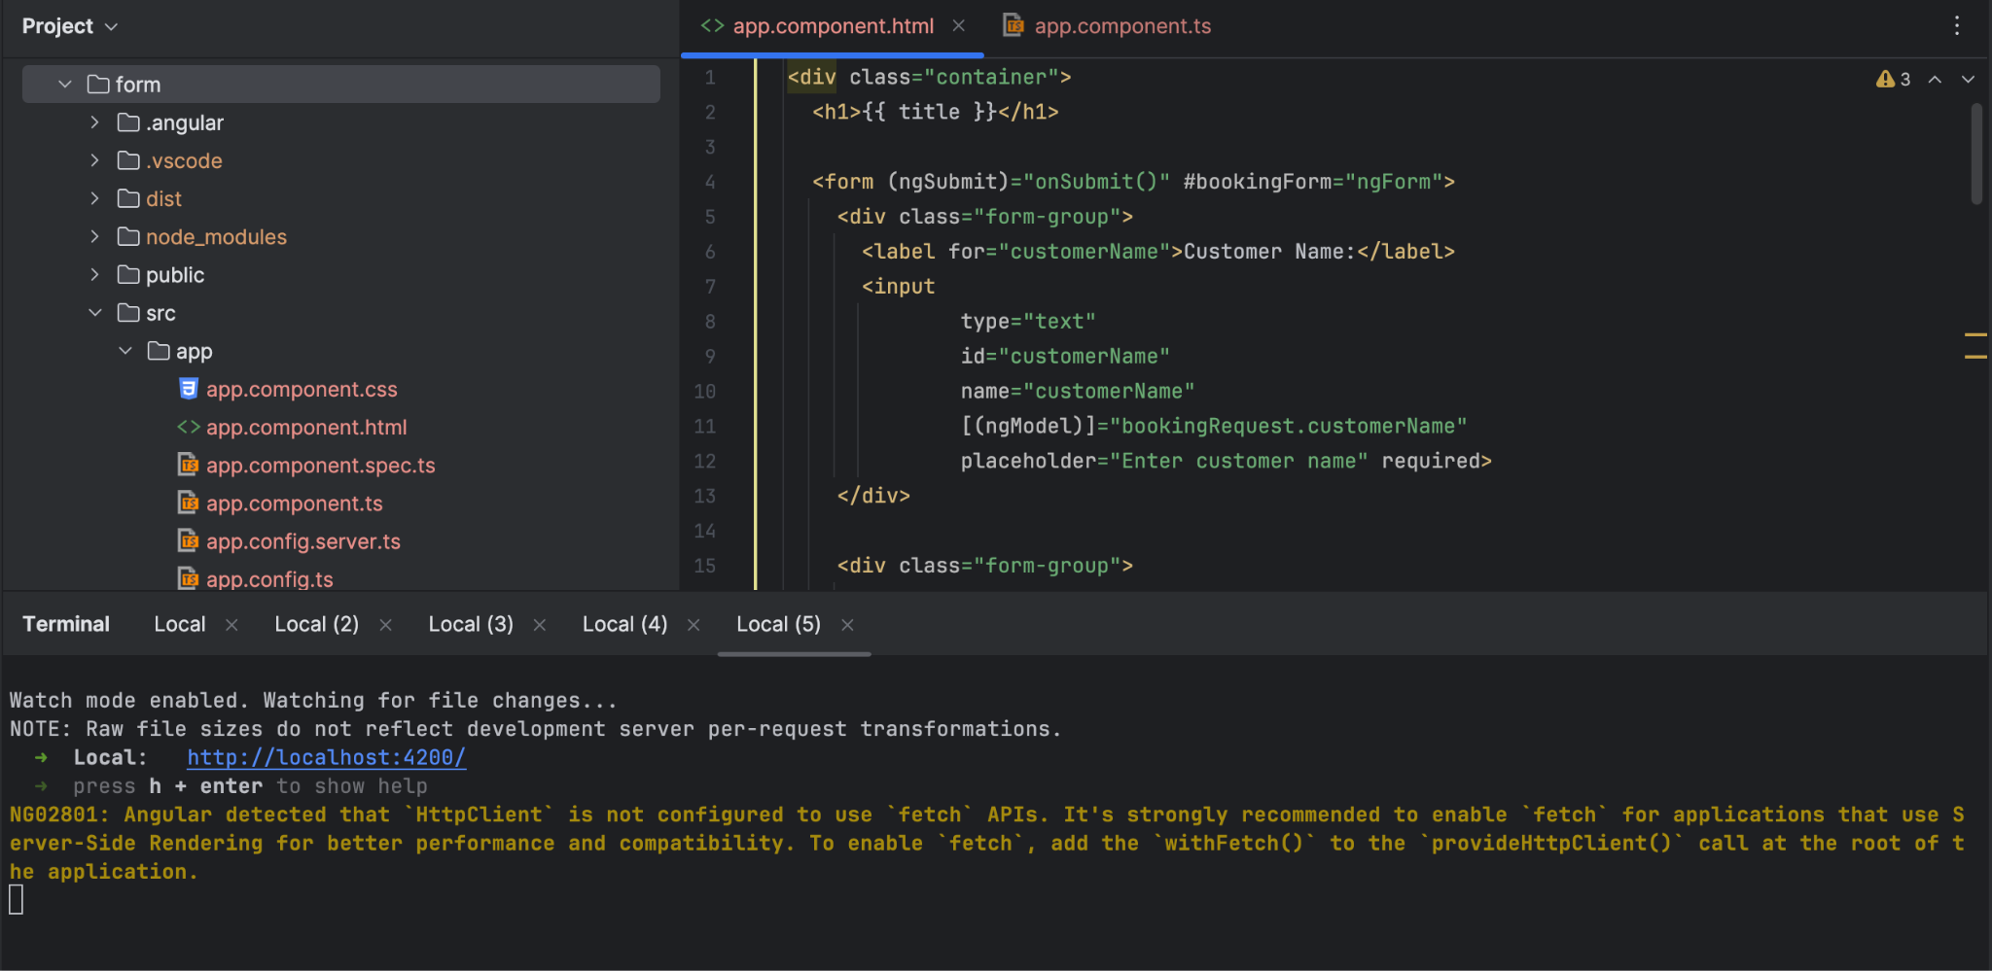

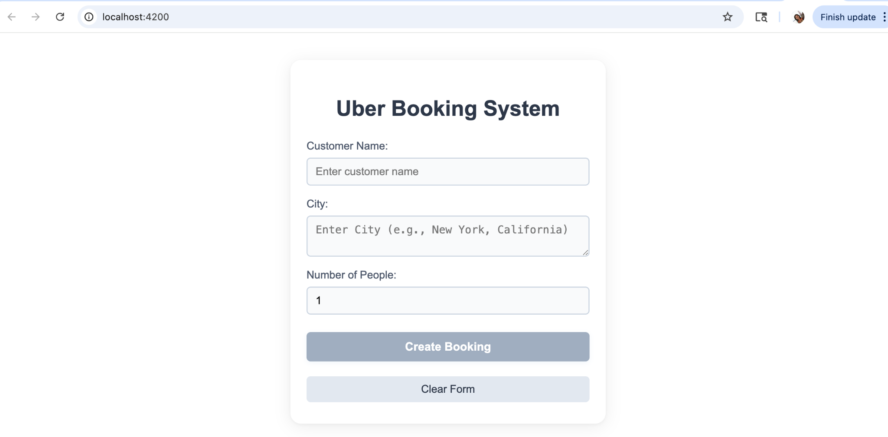

## 

## Step 13: Junit

1. Under booking-service package >> src >> [test.java.com](http://test.java.com) >> create uber package
2. Under uber > create Controller Package and Service Package
3. Under Controller package >> create “BookingControllerTest.java”
4. Under Service Package >> create “BookingServiceTest.java”

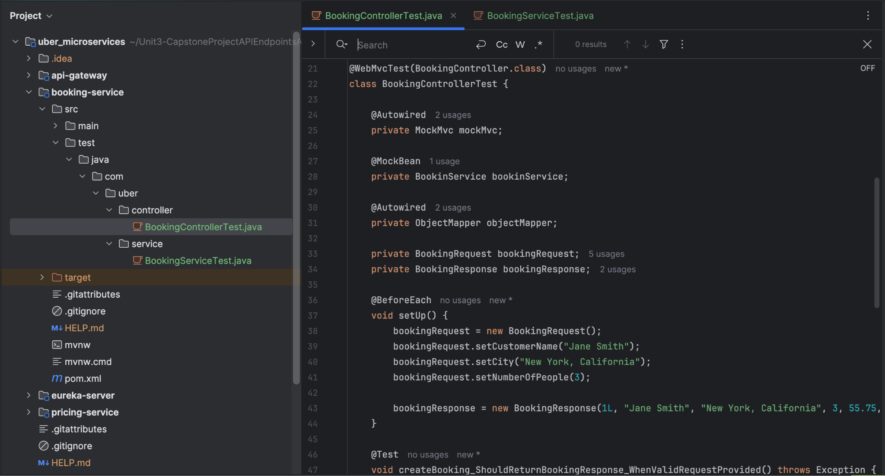

1. Add couple of test in booking-service >> test/java/com/uber/controller >> BookingControllerTest.java to:
   1. Verify if the create booking with valid request is provided
   2. Verify if the create booking with Invalid request provided will return a bad request with error validation.

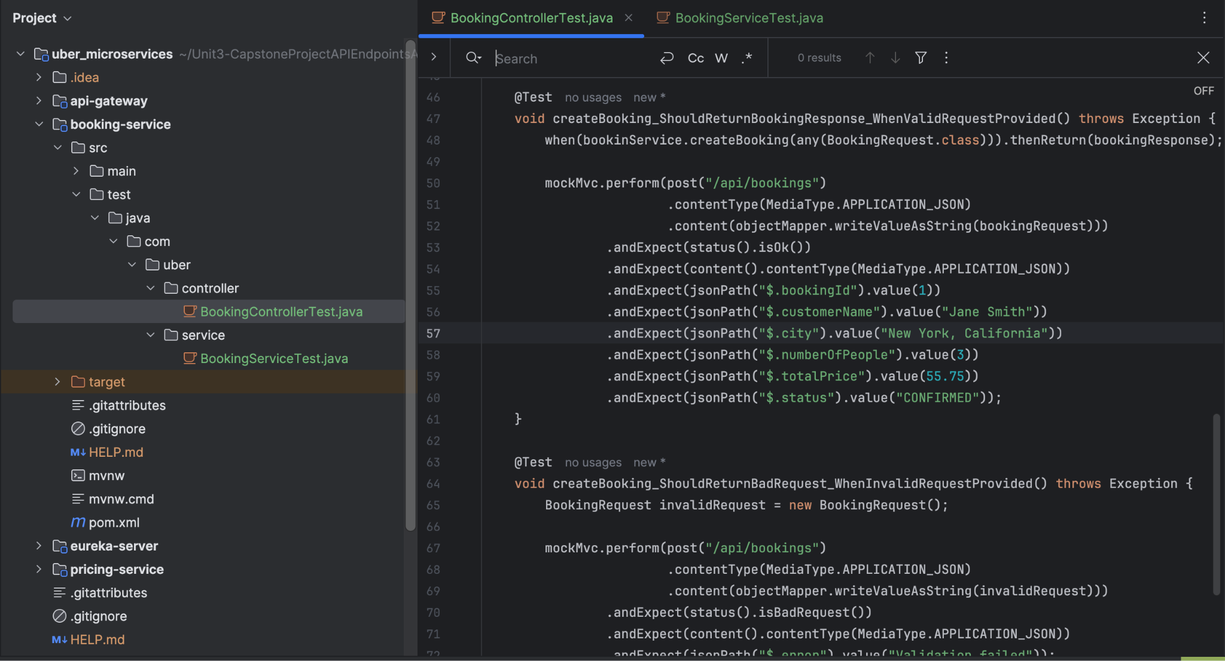

1. Add couple of test in booking-service >> test/java/com/uber/service >> BookingServiceTest.jas to:
   1. Validate the pricing service request while booking a cap returns booking with calculated price
   2. Validate when service is unavailable, to return booking with zero price with exception
   3. Validate multiple booking creates a unique booking Ids.

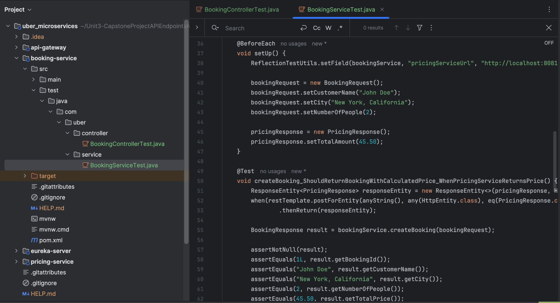

## Step 14: Run the all the services in the project

1. Run all the services in the order, by cd to the respective folder and enter the command [mvn spring-boot:run]:
   1. eureka-server
   2. api-gateway
   3. booking-service
   4. pricing-service

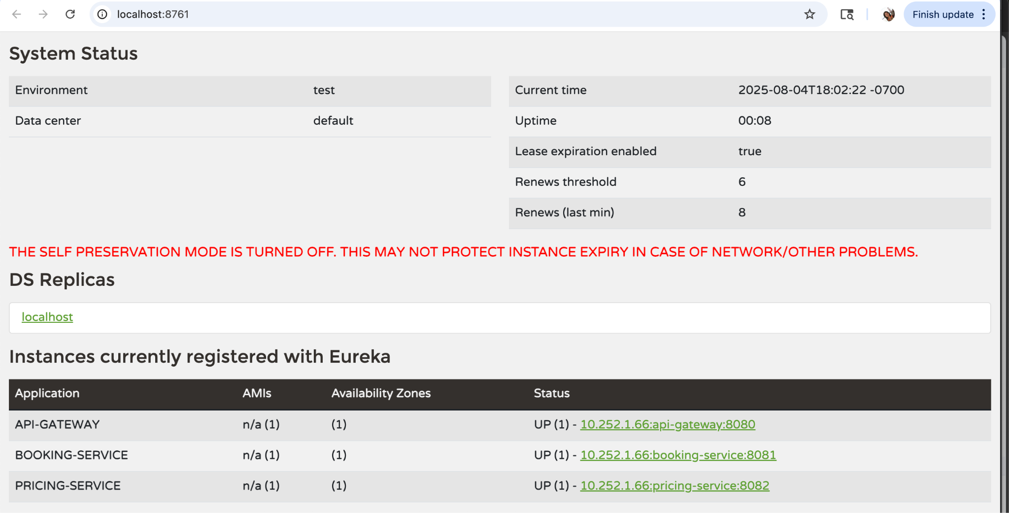

## Step 14: Run the Angular project

Run ng build or ng serve again after saving your changes to confirm the fix.

## End